 | Weekly Insights | Nov 20, 2025
 | Item | Page
 | Stories of the Week | 1
 | Corn | 30
 | Wheat | 32
 | Soybeans | 34
 | Soybean Meal | 36
 | Soybean Oil | 38
 | Weekly Prices | 40

Executive Summary
Corn – Strong Physical Demand Tightens Spreads Even as Heavy Stocks Cap the Board
March corn held in the mid-$4.40s this week, virtually unchanged, as robust export movement and record ethanol grind counterbalanced a still-comfortable balance sheet. The expiring Dec/Mar spread narrowed to about –11¢ (48 percent of full carry), reflecting firm nearby pull from Gulf exporters and ethanol plants bidding up December during delivery. Weekly export inspections came in at about 1.42 MMT, lifting season-to-date shipments to roughly 19.0 MMT, about 71 percent above last year’s pace and consistent with a program tracking above 2.9 bbu. USDA’s November WASDE held U.S ending stocks at 2.154 bbu, underscoring that while the balance sheet remains heavy on paper, cash strength continues to offset it. Basis values at the Gulf and key interior hubs stayed historically firm, with strong ethanol grind and export flows anchoring the front end of the curve.

Wheat – Global Surplus Looms, but U.S Export Execution Keeps Futures Above the Lows
Wheat futures traded around the mid-$5.40s (March SRW), holding recent gains despite a bearish global backdrop. The Dec/Mar SRW spread held near –12¢ (50 percent of carry), a sign that while ample stocks loom on paper, steady export execution (weekly U.S shipments still running about 20 percent ahead of last year on a cumulative basis) is preventing a heavier carry. Russian FOB offers remained near the low-$230s/MT, showing no supply shortage, but U.S export pace, especially to Latin America and Asia, has been resilient. That keeps the market supported above recent lows and keeps 901 mbu feeling more like a ceiling to probe than a surplus the market is being forced to clear. Plains winter wheat areas continue to monitor dryness, but no major weather premium has re-entered the board.
Soybeans – Chinese Demand Optimism Lifts Board as Tight Spreads Signal Nearby Strength
January soybeans briefly pushed into the $11.40s on optimism around Chinese demand, before settling near $11.20/bu by mid-week. Cash fundamentals underpinned the board: Gulf basis and interior processor bids stayed unseasonably strong, and record U.S crush margins persist. The Jan/Mar spread is now barely –9¢ carry (41 percent of full carry), tightening from –7¢ last week, signaling tight nearby availability as crushers and exporters compete for beans. Weekly inspections around 0.92 MMT brought season-to-date shipments to roughly 11.9 MMT (about 46 percent behind last year’s pace), still soft historically but improving as recent Chinese purchases begin to ship. The market continues to weigh solid U.S demand against massive projected South American supply. China “flash” purchases offered support post-holiday, but follow-through will be critical for maintaining board strength into year-end.
(Carry % calculated assuming 7% annual interest and \$0.05/bu per month storage/insurance cost over the spread interval.)

Macro / Policy – Mixed Signals: Softer Crude, Stable USD, and Policy Shifts in China & Argentina
Broad market drivers were neutral. Crude oil hovered around $59/barrel, offering modest relief to freight and input costs but pressuring biofuel margins. The U.S Dollar Index held near 100, while the Brazilian real was steady around R$5.27/USD. In Argentina, the black-market peso continued to weaken, nearing ₱1450/USD in parallel markets ahead of the new administration’s term, preserving aggressive farmer selling incentives. Trade policy signals were mixed: China’s suspension of tariffs on U.S corn and wheat remains in effect (though no major U.S corn purchases yet), and the 10–13 percent import duty on U.S soybeans still applies. However, recent U.S soy purchases may be for state reserves, effectively sidestepping that tariff. Meanwhile, Argentina’s president-elect reaffirmed plans to slash grain export taxes – a medium-term bearish wildcard if implemented quickly.
Weather – U.S Harvest Wraps Cleanly, Brazil Splits Into North-Wet / South-Dry, Argentina Near Ideal

U.S harvest is essentially complete (corn and soybeans both above 95 percent), shifting attention fully to South America. In Brazil, soybean and first corn planting is nearing the finish line under mixed conditions: central and northern areas benefited from improved late-November rains, while parts of the far south (Rio Grande do Sul, Santa Catarina) and pockets of MATOPIBA saw below-average rainfall. This emerging La Niña pattern raises yield risk in southern Brazil even as it aids some northern soy areas. Argentina’s early crop development remains favorable: ample spring rainfall has boosted soil moisture, supporting rapid corn and soybean planting and a recovery from last year’s drought. With USDA already assuming record Brazilian and Argentine crops, any persistence of southern Brazilian dryness or a shift to drier conditions in Argentina would quickly become an active driver of spreads and flat price.
What’s Next (Dec 4 – Dec 10):
USDA December WASDE (Dec 9): Markets await the mid-December World Agricultural Supply and Demand Estimates.
Export Sales & Inspections: With the holiday behind, weekly export sales and inspections will be parsed to confirm how much of the recent Chinese soybean buying is on the books.
South American Weather Pattern: The next 7–10 days are critical for Brazil. If rains remain scant in far southern Brazil while the Center-West stays ideal, the divergence in crop conditions may widen, potentially supporting soybean meal and nearby corn spreads.
Argentina Policy Announcements: Argentina’s new government takes office Dec 10. Any official decrees on currency devaluation or export tax cuts (especially for corn/wheat) could trigger immediate reactions
Logistics – River & Ports: U.S attention turns to rail and barge logistics as winter sets in. River levels on the Mississippi and Ohio have improved from early-fall lows, but weather disruptions remain possible.
Table A – CME Futures (Front Contracts)
(Prices in USD per bushel, volume/open interest in contracts)
Contract (Front Month) | 11/20/2025 Close | 12/03/2025 Close | Change (Δ) | Δ% | 5-day Realized Vol* (x) | Open Interest Δ  (x)
Corn (Dec ’25) | $4.35 | $4.33 | +0.01$ | +0.23% | 12% (ann.) | +2k (est.)
Soybeans (Jan ’25) | $10.9 | $11.3 | +0.4$ | +3.67% | 14% (ann.) | +5k (est.)
Wheat (Dec ’25) | $5.32 | $5.38 | +0.06$ | +1.13% | 13% (ann.) | +1k (est.)
5-day realized volatility estimated from daily settlement price changes.
Actual contract open interest changes are estimated; total corn OI rose slightly as new-crop hedges built, while wheat OI fell with Sep contract deliveries.
Table B – Key Calendar Spreads & % of Full Carry
Spread (Crop ‘25→‘26) | 11/20  Quote | 12/03  Quote | Δ (carry) | % Full Carry* | Market Implication
Corn Dec–Mar | -$0.13 | -$0.11 | +0.02 | 48%
  Nearby Gulf demand firming vs. interior harvest flow
Soy Jan–Mar | -$0.011 | -$0.09 | +0.02 | 41% | Crush pull holding January, export sales still Brazil-facing
Wheat Dec–Mar | -$0.13 | -$0.12 | +0.01 | 50% | Heavier global stocks rewarding storage; no scarcity signal
Assumes 7% annual interest + $0.05/bu/month storage/insurance. Full carry (3 months) ≈ $0.22–$0.23 for corn & SRW wheat; (2 months) ≈ $0.22 for soybeans. % of full carry = (calendar spread ÷ calculated full carry).
Table C – Notable International Futures (weekly moves, if significant):
Exchange (Front Month) | 11/19 USD Price | 12/03 USD Price | Δ% | Notes
Dalian Corn (Jan) | ¥2,162($6.49/bu) | $2,169 ($6.50/bu) | +0.3% | Steady on local crop debate, limited directional momentum.
Dalian Soymeal (Jan) | ¥2,994 ($421/mt) |  | +1.8% | Meal futures firmed on tightening near-term supplies; domestic crushers slowed runs.
  $3,048 ($89/mt)
B3 (São Paulo) Corn (Nov) | R$67.88 ($12.38) |  | +0.3%
  R$68.10 ($12.93)
  Brazil domestic futures slightly firmer; improved Center-West rains offset by southern dryness.
Euronext Wheat (Dec) | €197.5 ($225/mt) |  | -2.0% | Lower on rising EU stocks; bids at €189, offers at €194.75.
  €193 ($5.28/mt)

Corn Market Deep Dive
South America Outlook: South American production is the major wildcard for Q1. In Brazil, CONAB projects 2025/26 corn output at 138.8 MMT, slightly below last year’s record (141 MMT), while we estimate the crop closer to 136 MMT, reflecting a planted area of about 22.72 million hectares (+4 percent YoY) and an expected yield just under 6.0 t/ha. Both agencies converge on the same acreage expansion, but yield remains the key swing factor: CONAB assumes 6.11 t/ha, embedding a stronger La Niña risk premium for the southern states, whereas our slightly lower yield expectation reflects a more cautious view of early-season stress in Rio Grande do Sul and parts of Paraná even as conditions in the Center-West remain supportive.
As of early December, northern and central Brazil (Mato Grosso, Goiás) are generally in good shape: recent rains helped rebuild soil moisture and enabled excellent early development. By contrast, southern Brazil (Paraná, Rio Grande do Sul) remains drier than ideal, and the planting window is closing rapidly. Moisture deficits in RS remain a key watchpoint for first-crop yields and the timing of safrinha planting, which begins in January and is particularly sensitive to delays. Meanwhile, Argentina’s corn outlook has brightened significantly: the Buenos Aires Grain Exchange pegs the crop at 61 MMT, while private forecasts stretch toward 58–62 MMT under trend-beating yield assumptions. Early planting benefited from abundant spring rains, and field conditions are excellent, but January weather will be decisive.
If these production outlooks hold, combined Brazil + Argentina output would still deliver a sizable global surplus, capping CBOT rallies through late Q1. But if southern Brazil’s dryness intensifies or Argentina turns drier during pollination, the global supply narrative could quickly tighten.
Futures & Spreads: March corn traded essentially flat on the week, holding near $4.43/bu as strong physical demand continued to offset the comfort of the broader supply backdrop. The nearby Dec–Mar spread tightened to –11¢, representing roughly 48 percent of full carry and signaling firm nearby demand from Gulf exporters and ethanol plants even as overall stocks remain ample. Volatility held low near 12 percent annualized, with no indication of stress or inversion in the curve. Futures remain locked in a mid-$4 range, but the softening carry structure shows that users are still pulling hard on the front end.
Export Demand & Cash Basis: Weekly corn inspections totaled 1.421 MMT for the week ending Nov 27, down from 1.696 MMT the prior week due to the Thanksgiving holiday but still 50% above the same week last year. Season-to-date shipments reached 18.97 MMT, roughly 71% ahead of 2024/25, and well aligned with an export program tracking above 2.9 bbu. Demand remains broad-based, led by Mexico, Colombia, Japan, and South Korea. Cash markets continue to validate this strength: CIF Gulf bids firmed another few cents and remain near multi-year winter highs, while ethanol plants in Iowa and Nebraska continue aggressive bidding amid record-high U.S ethanol output of 1.201 mb/d, implying one of the strongest weekly corn grinds ever. Together, basis, spreads, and inspections paint a picture of a physical market far sturdier than the paper balance sheet suggests.
U.S Balance Sheet: The November WASDE held U.S ending stocks at 2.154 bbu, about 44 mbu above the prior estimate, keeping the 2025/26 stocks-to-use ratio near 14 percent, comfortable enough to cap flat-price rallies. But the physical pipeline remains tight: exports are outperforming early-season expectations, ethanol grind is running at or near record pace, and basis levels have stayed historically firm for late November. Until stronger farmer selling returns or export momentum slows, the board is struggling to reflect the looseness implied by carryout.
So What? Corn continues to trade a split narrative: futures see comfortable stocks and the prospect of massive South American production, while the cash market sees strong real-time demand and refuses to loosen. Export pace, ethanol grind, and basis strength are anchoring the front end, narrowing spreads and preventing breakdowns. At the same time, the shadow of a potential 195 MMT combined Brazil + Argentina corn crop limits any sustained rally. Unless a demand shock (such as China returning as a large buyer) or a weather disruption materializes, corn is likely to remain range-bound between $4.25 and $4.50/bu, firm on breaks, capped on rallies, and increasingly sensitive to every South American forecast update.

Soybean Market Deep Dive
South American Outlook: Brazil remains the dominant force in global soybean pricing. CONAB estimates 2025/26 production at 177.6 MMT on 49.06 Mha planted, with yields near 3.62 t/ha. Our updated forecast is higher at 179 MMT, assuming 49.25 Mha planted and a stronger yield profile near 3.66 t/ha. Expansion is centered in MATOPIBA and frontier regions where farmer margins remain attractive. Central and northern areas (Mato Grosso, Goiás) recovered well after early-season dryness thanks to late November rains, while Rio Grande do Sul and Paraná continue to experience below-average moisture, a classic La Niña signature. If southern dryness persists through January, Brazil’s soybean crop could slide toward 175–178 MMT, if rains normalize, 180 MMT remains the base case.
Argentina’s production outlook has improved dramatically versus last year. The Buenos Aires Grain Exchange keeps its estimate near 50–52 MMT, but private models suggest potential for 55–56 MMT under current moisture conditions. Planting progress is ahead of normal, soil moisture is excellent, and early vegetative growth is strong. The swing factor is policy: talk of lowering or restructuring soybean export taxes could shift planting behavior and marketing pace, adding another layer of uncertainty for Q1 global flows. Combined Brazil + Argentina production could exceed 235–238 MMT, easily surpassing last year and increasing global ending stocks beyond USDA’s 121.99 MMT projection.
Futures & Spreads: January soybeans ended the week little changed, briefly pushing into the low $11.40s before fading back toward $11.20/bu as the rally failed to build momentum. The market remains split between strong near-term U.S demand and the gravitational pull of massive South American supply expectations. The Jan/Mar spread tightened to –9¢ (41 percent of full carry), signaling firm nearby demand from crushers and exporters even as the flat price struggles to break out. CIF NOLA barge bids and Eastern Corn Belt processor basis stayed historically strong for early December, reflecting a pipeline that is tighter than the balance sheet implies, processors and exporters are still competing for physical beans.
Crush Margins & Domestic Demand: Domestic crush is the backbone of U.S soybean strength. October NOPA crush hit a record 227.7 mbu, and industry chatter indicates that November crush stayed extremely strong supported by favorable board margins and resilient soymeal demand. Soymeal remains the star component: livestock and poultry sectors continue to pull aggressively, keeping interior processor basis elevated. Soyoil softened alongside weaker diesel prices, but renewable diesel policy (45Z anticipation, state LCFS incentives) continues to support crush margins. USDA left 2025/26 crush at 2.55 bbu, but the margin structure hints at upside risk if processors maintain current run rates.
Export Sales & Inspections: Weekly soybean export inspections were 0.92 MMT, bringing cumulative shipments to 11.87 MMT, still about 30–35 percent behind last year but improving as recent Chinese purchases begin to ship. Over the past two weeks, USDA confirmed roughly 1.6 MMT of U.S soybeans sold to China, some likely destined for state reserves. These large flashes temporarily extended the U.S export window amid Panama Canal congestion and Brazil’s slower early planting. Still, the sales book remains fragile: USDA’s 1.635 bbu export target requires sustained Chinese buying into January/February. Without continued follow-through, the export line will face downward pressure in the January WASDE.
So What? Soybeans are trading between two powerful forces: a firm U.S physical pipeline in the short run and the potential for overwhelming South American supply in the medium run. Tight Jan/Mar spreads, strong crush, and improving exports keep the market supported for now, but the board cannot rally meaningfully while Brazil and Argentina point toward record or near-record crops. If southern Brazil’s dryness deepens or Argentina turns hot/dry during flowering, soybeans could quickly add a weather premium. But if rains stabilize and Chinese buying fades, futures will struggle to hold the $11 range as Q1 approaches. In effect, the soybean market is pricing time, strength now, risk later, and the next 6–7 weeks of South American weather will determine which narrative wins.

Wheat Market Deep Dive
Futures & Spreads: March SRW wheat traded in a narrow range this week, settling near $5.41/bu as the market continued to digest the mid-November WASDE’s heavier supply outlook. Early-week weakness gave way to a modest rebound driven by short-covering and another week of firm export execution. The Mar/May spread held near –12¢ (50 percent of full commercial carry), slightly firmer than early November but still consistent with a storage-rewarding structure rather than any sign of nearby tightness. Volatility remains muted, and with funds still net short (but no longer adding aggressively), the curve is broadcasting a classic carry market, one characterized by burdensome stocks offset by demand steadiness that prevents further breakdown.
Global Supply & Trade Pressure: The November WASDE confirmed a heavy global backdrop: 2025/26 world wheat production at 828.9 MMT and ending stocks at 271.4 MMT, both above September and above pre-report expectations. Russia remains the dominant bearish anchor, with production near 86.5 MMT, exports at 44 MMT, and FOB 12.5% protein offers still around $230/MT, comfortably undercutting U.S and EU values. Black Sea export flow remains aggressive, though rising Russian internal prices and steadily increasing export taxes could become mild friction points by Q1. For now, however, Russia continues to set the global ceiling, and U.S wheat must price competitively to capture incremental demand.
Cash & Basis: FOB U.S Gulf SRW wheat hovered near $230/MT ($6.85/bu equivalent), maintaining a $20–25/MT premium to Russian offers into North Africa and Asia. This premium reflects quality and freight, but underscores the structural disadvantage U.S wheat faces internationally. Domestic basis is soft in most regions but shows pockets of firmness: HRW basis in the Southern Plains improved slightly as feeders capitalized on cheap wheat relative to corn. Still, with carry near 50 percent of full and no significant FOB tightening, the U.S cash market remains firmly in “storage mode,” not approaching any scarcity threshold.
Trade Flows: U.S export performance remains modest by historical standards but continues to run well ahead of last year. Weekly export inspections for the week ending Nov 27 came in at 384,881 MT (correct), pushing cumulative 2025/26 shipments to 13.23 MMT, about 20 percent above the same period last year (11.03 MMT). The steady outflow keeps USDA’s 900 mbu export projection possible, though still requiring persistent execution through winter. Strength has come largely from Latin America (Mexico, Brazil) and steady Asian demand (Philippines, Japan). A slightly weaker U.S dollar and stable freight have improved competitiveness at the margin. Even so, the U.S remains a secondary supplier in most global tenders, execution must remain strong to keep the export line on track.

So What? The wheat market continues walking the line between heavy global supply and incremental demand resilience. U.S ending stocks stand at 901 mbu, world stocks above 271 MMT, and Black Sea wheat continues to set the global floor. Yet futures have stabilized in the $5.20–$5.60/bu range, supported by steady U.S shipments and perceptions that U.S SRW is already “cheap enough” to discourage further fund selling. The market is not ignoring the surplus, it simply sees no urgency to push prices dramatically lower. Chicago remains a classic carry market, biding time until a catalyst emerges: Black Sea logistical disruption, Southern Hemisphere harvest shortfalls, or meaningful U.S winter wheat stress. Until then, wheat is a carry trade, not a scarcity story.

US Cash Market & Basis
Corn: Cash corn basis remains historically firm for winter, with CIF Gulf bids quoted near +90¢ to +95¢ over March futures, levels rarely seen this time of year. Interior bids, particularly in the ethanol-heavy Western Corn Belt, remain strong, with processors actively competing for spot bushels. Basis in Iowa and Nebraska held firm to slightly higher on the week, supported by ethanol production that hit a record high of 1.126 million barrels/day at the end of November. National basis sits around –34¢ under March, roughly 5¢ firmer than the same time last year. The strength reflects a combination of robust domestic demand, lean commercial ownership, and reluctant post-harvest farmer selling, many growers opted to store rather than sell amid low flat prices and anticipation of better marketing opportunities ahead. While the futures board continues to reflect a comfortable balance sheet, the basis structure tells a story of tight nearby availability and strong pipeline pull.
Soybeans: Soybean basis is even tighter than corn. CIF Gulf barges for January are trading near +80¢ over Jan futures, down slightly from recent highs but still strong by historical standards. Interior processor basis remains exceptionally firm, with spot bids in the Eastern Corn Belt (e.g. Decatur, Lafayette) at +60¢ to +75¢ over Jan, driven by record crush margins and steady soymeal demand. River elevators along the Mississippi and Ohio have also firmed amid improving barge logistics and lingering export interest from China. National basis averages near –26¢ under Jan, well above typical harvest-season levels. The recent tightening of the Jan/Mar spread to –9¢ is consistent with this cash firmness. U.S exporters are working through a burst of late-season Chinese sales, but forward basis values have started to soften slightly as Brazil’s export season approaches. Cheaper South American offers for March forward slots are already pressuring U.S FOB values, and exporters know they must stay competitive to defend market share in early Q1.
Wheat: Wheat basis remains the weakest of the major row crops, but still stable given the heavier supply backdrop. FOB Gulf SRW prices sit near $230/MT ($6.26/bu equivalent), a level that has attracted some interest but still leaves U.S wheat $20–25/MT above Black Sea offers, particularly from Russia. Russian 12.5% protein wheat remains anchored near the low $230s/MT, and with freight advantages into North Africa and Asia, continues to set the marginal price ceiling. In the interior U.S, HRW basis in the Southern Plains showed minor strength this week in feed markets, as wheat remains competitive with expensive corn in some rations. Elsewhere, basis was mostly steady to soft, in line with a comfortable carry market. USDA’s 900 mbu export target remains achievable, but only if shipment pace continues and FOB premiums remain defensible. For now, U.S wheat remains a storage market, not a basis-driven one.

International Cash & Trade Flows
Brazil: Brazil remains the global leader in grain export flows, even as seasonal slowdowns take hold. November corn exports reached an estimated 5.5–6.0 MMT, slightly down from October’s record but still robust thanks to Brazil’s massive safrinha corn crop. Soybean exports fell to 2–3 MMT as old-crop supplies dwindled ahead of the new harvest cycle. FOB Santos soybean offers averaged $485–490/MT ($11.15–$11.25/bu), holding a $10–15/MT discount to U.S Gulf quotes for January loading. On corn, Paranaguá FOB offers hovered near $205/MT ($5.20/bu), keeping Brazil firmly in control of Asian and Middle Eastern destinations. Logistics through Santos and other corridors remain fluid, with no major reports of congestion or freight delays. Central and northern soybean fields saw timely rains in late November, improving early development, but lingering subsoil moisture deficits in parts of Goiás and the MATOPIBA region may temper yield optimism slightly. Still, for now, Brazil remains the benchmark origin for global corn and soybean trade into early 2026.
Argentina: Argentine export prices softened slightly in early December, weighed down by currency shifts and political uncertainty. FOB corn (Rosario) offers were quoted near $180–185/MT, while FOB soybeans dipped to $430–435/MT, both a touch weaker than November levels. Farmer selling has slowed again after the expiration of the "soy dollar" FX incentive in October and in anticipation of the Dec 10 government changeover, which could include a formal peso devaluation and lower export taxes. With informal exchange rates ballooning to ₱1,450–1460/USD in parallel markets, many growers are opting to hold soybeans as a currency hedge, particularly ahead of expected policy clarity. Nonetheless, crush plants around Rosario continue to operate steadily, drawing on stocks accumulated earlier in Q4. Planting progress is strong: corn and soybean seeding both near 50 percent complete, supported by ample early rainfall. Corn output is projected around 60–62 MMT, and soybeans at 50–55 MMT, a significant recovery from last year’s drought-stricken campaign. Wheat harvest has begun in the north under mostly favorable conditions, with 2025/26 production pegged around 16.5–17 MMT.
China: Chinese grain buying remains price-sensitive and cautious. U.S Gulf soybeans are offered at +240¢/bu over Jan futures ($2.40/bu basis), which is 15¢/bu higher than Brazilian offers, keeping Brazil as the favored origin for January/February deliveries. Chinese crushers booked additional Brazilian cargoes in late November, while recent U.S sales are assumed to be for state reserves, not commercial crushing. On corn, the Dec 1 removal of retaliatory tariffs on U.S grain has not yet triggered fresh demand, Chinese buyers appear to be waiting for lower U.S prices or further policy clarity. Dalian Jan corn futures (¥2,140/MT) remain well above world values ($6.40/bu equivalent), but internal buying appetite is still tentative. For now, China is nibbling at U.S soy, avoiding corn, and watching the market closely, not yet pivoting back to U.S origin in volume.
EU / Black Sea: The Black Sea continues to define world grain prices. Russian 12.5 percent protein wheat FOB offers firmed slightly to $235–240/MT, lifted by ruble stabilization and a higher floating export tax. But Russian shipments into North Africa and the Middle East remain strong, reinforcing their grip on price-sensitive tenders. French wheat (FOB Rouen) near $230/MT remains at a discount to U.S Gulf wheat, but still trails Russia in competitiveness. Ukrainian corn flows via Danube barges and rail continue steadily into Europe, with offers around $205–210/MT, pressuring EU feed grain values. Internal EU stocks are sufficient post-harvest, reducing short-term import demand. In protein meals, Black Sea soymeal (Russia, Ukraine) is pricing below U.S origin and gaining share in southern Europe and the Middle East, aided by cheaper freight and favorable FX terms.
Other Origins: No major changes from secondary exporters. Canada continues to ship spring wheat into Asia and Mexico but remains a supplemental supplier. Australia’s wheat harvest is underway: Eastern states report decent quality and protein, but Western Australia’s ongoing drought is dragging national yield lower. Buyers expect mixed quality and smaller volumes than last year’s record crop. India remains sidelined from export markets, with wheat and rice restrictions still active and no new policy guidance. South Africa’s summer crop season is proceeding normally, and no significant disruptions have emerged from other minor global suppliers.
So What? Global grain flows remain clearly bifurcated: Brazil and Russia dominate corn, soybeans, and wheat, respectively, while U.S exporters play a secondary role, relying on regional advantages and niche opportunities (e.g. corn to Mexico, soymeal to inland Asia, wheat to Latin America). The FOB spread remains structurally wide, Brazilian corn/soy and Russian wheat continue to price below U.S Gulf equivalents even with strong U.S basis and logistics. Unless weather, policy, or demand dynamics shift materially, such as a South American crop shortfall or China returning as a consistent U.S buyer, the U.S position in global flows will remain tactical rather than dominant.
Key Fundamentals & Reports (Nov 21 – Dec 4)
Government Data & Reporting: USDA data flow remained uninterrupted this week, with Export Inspections and Sales reports released on time and no major scheduling delays reported. The market is now turning its attention to the upcoming December WASDE (scheduled for Dec 9), which is not expected to bring significant U.S balance sheet changes but may offer early guidance on South American crop prospects or export line revisions. The return of CFTC Commitments of Traders reporting has restored visibility into fund positioning, though speculative flows remain light overall.
Crop Progress: National harvest is now essentially complete. USDA did not publish a new Crop Progress report during this period, as corn and soybean harvests are considered wrapped up for statistical purposes. Private surveys and regional updates confirm that fieldwork has concluded across most of the Corn Belt. In winter wheat, the market remains focused on condition ratings and drought persistence in the central and southern Plains, particularly western Kansas and Oklahoma. Early-season HRW ratings are mixed, and emergence is proceeding at a normal pace, though some key areas remain moisture-deficient as dormancy sets in.
Export Inspections (USDA FGIS – week ending Nov 28): Corn inspections totaled 1.42 MMT, a holiday-shortened volume but still well above last year’s 0.95 MMT for the same week. Season-to-date corn loadings have reached 18.97 MMT, running 70 percent ahead of last year and staying comfortably aligned with USDA’s upgraded 2.3 bbu export forecast. Soybean inspections came in at 0.92 MMT, bringing cumulative shipments to 11.87 MMT, still sharply below last year’s front-loaded pace, but improving modestly in recent weeks as Chinese purchases begin to ship. Wheat inspections were 384,881 MT, lifting cumulative exports to 13.23 MMT, roughly 20 percent above last year’s levels and broadly consistent with USDA’s 900 mbu export projection. Despite seasonal slowing, physical movement remains supportive across corn and wheat, while soybeans continue to rely on incremental Chinese demand to narrow the year-over-year deficit.
Export Sales (USDA FAS – week ending October 30): Export sales data highlighted steady activity across major commodities amid ongoing catch-up reporting due to funding delays. For corn, net sales reached 2.36 MMT with exports at 1.54 MMT, led by consistent demand from markets like Mexico, Colombia, and Japan, staying aligned with the pace needed to hit USDA’s approximately 2.975 bbu forecast. Soybeans saw a solid performance with net sales of 1.33 MMT and exports at 1.03 MMT; recent daily announcements include about 0.435 MMT in net Chinese purchases in late November (e.g., 312,000 MT on November 28 and 123,000 MT on November 24), linked to a new U.S-China deal for 12 MMT in November-December, some potentially for state reserves. These flows are helping narrow the year-on-year deficit, though total commitments remain behind the seasonal average. Wheat sales were modest at 0.53 MMT net with exports at 0.30 MMT, unchanged versus recent weeks; a daily sale of about 133,000 MT of white wheat to China was reported on November 20, but overall, China has not yet emerged as a significant buyer ahead of the December 1 tariff suspension. Traders are watching for confirmation of additional business in the December 8 catch-up report. Overall, the sales tone improved, but forward book growth will need to accelerate into January to justify USDA’s current export lines.
Ethanol Production & Stocks (EIA – week ending Nov 29): U.S ethanol production continued its strong late-November run, with output rising to 1.126 million barrels/day in the week ending Nov 28, the highest level of the month and up from 1.113 mb/d the prior week. The four-week trend has held between 1.07–1.13 mb/d, confirming steady industrial demand and a consistently firm pull from Western Corn Belt processors. At current yields, the latest print implies a weekly corn grind of roughly 100–102 million bushels, supportive of nearby basis and spreads. Ethanol stocks ticked slightly higher, in line with normal pre-year-end seasonal builds, while margins remain comfortably positive thanks to stable corn prices and resilient DDGS values.
So What? Market sentiment this week was driven more by real-time signals than static supply numbers. In corn, record ethanol output and strong inspections provided firm demand-side support even as carryout remains heavy. Soybeans benefited from confirmed Chinese purchases and continued crush strength, helping offset the lagging export book. Wheat remains the weakest on paper, but decent export execution and limited fund pressure have helped it stabilize near mid-range levels. With no new WASDE revisions yet and no South American crop cuts confirmed, traders continue to lean on physical indicators, basis, inspections, processor bids, to define near-term direction. Futures are range-bound, but underlying demand in corn and soy continues to validate board values even as global supply caps any sustained rallies.

Weather & Crop Conditions
United States
Crop Progress & Logistics: U.S harvest has officially concluded, with both corn and soybean collection finishing well ahead of the five-year average. Dry autumn conditions enabled rapid progress and minimal quality issues. With row crops off the field, attention has shifted to winter wheat and infrastructure. Winter wheat entered dormancy with a generally decent start, although key HRW areas in western Kansas and the Texas Panhandle remain moisture deficient. Soil moisture is mostly adequate elsewhere, but spring recharge will be essential in the drought-prone southern Plains. River levels, meanwhile, have rebounded meaningfully from October’s historic lows: gauges at Memphis, St. Louis and Baton Rouge all showed firm improvements, allowing barge drafts to normalize. Navigation on the Lower Mississippi and Ohio Rivers is now operating under standard conditions, a positive shift for basis and export flow into year-end.
Temperatures & Energy: Mild early-winter weather across the U.S and Europe has helped hold natural gas prices steady, with no polar vortex threats or significant frost events reported. For grain markets, this reduces fertilizer cost pressure and keeps winterkill risks low. NOAA’s near-term outlook (6–10 day) shows seasonal to above-normal temperatures in the Midwest and Plains, with limited precipitation expected for the southwestern HRW belt.
Brazil
North–South Weather Divide Deepens: Brazil’s weather pattern remained sharply split between northern and southern regions, a classic signal of the emerging La Niña. November’s second half delivered consistent rains across Mato Grosso, Goiás and MATOPIBA, supporting strong soybean and first-crop corn emergence. Planting is essentially complete in those zones, with agronomists noting “very good” early stand ratings and topsoil moisture at or above normal. However, southern states like Rio Grande do Sul and Santa Catarina stayed dry through late November and early December. Farmers in Paraná benefited from earlier rains, allowing for good crop establishment, but later-planted fields in Rio Grande do Sul are now entering reproductive stages under significant moisture stress.
Scattered early-December showers offered minor relief, but forecasts from INMET and NOAA signal subpar rainfall across southern Brazil through at least mid-December. This is a critical window: first-crop corn is nearing tasseling and early soybeans are moving into pod set. If dryness persists, yield loss in the far south will become increasingly likely, potentially offsetting northern gains and trimming Brazil’s record production potential. In MATOPIBA, improved rainfall since late October has firmed up yield prospects, especially in irrigated zones of Bahia and Piauí. Port logistics and interior freight flows remain unimpeded by weather to date.
Argentina
Planting Surge & Favorable Conditions: Argentina’s planting and early crop development continue to progress under broadly favorable conditions. Soybean sowing accelerated meaningfully last week, advancing 8.7 percentage points to cover roughly 44–45 percent of the projected 17.6 MHa for 2025/26. Despite the strong weekly push, planting remains about 9 points behind last year and slightly below the five-year average due to field-access issues in parts of central Buenos Aires, where excessive moisture has slowed machinery entry. In contrast, first-crop soybean planting across both core regions is nearing completion, and second-crop soybeans are now gaining momentum as winter grain harvest wraps up.
Corn planting reached about 44 percent of intended area after a solid 5-point weekly gain, with late-window sowing opening up across the central and southern agricultural belt. Crop conditions are exceptionally strong: 86 percent of planted corn is rated Good to Excellent, supported by widespread soil moisture recharge. Nationally, 94 percent of the agricultural area sits within Adequate Optimal moisture ranges, one of the best early-season profiles in recent years. While localized excess moisture persists in the Southern Core and pockets of central Buenos Aires, these issues have not altered the overall narrative. Ample subsoil reserves are ensuring uniform emergence and strong early vegetative development, placing Argentina on a trajectory consistent with above-trend yield potential heading into the critical January weather window.
Global
Winter Wheat & Australian Harvest: The Northern Hemisphere’s winter crops entered dormancy under mostly favorable conditions. Russia, Ukraine, France and Germany all reported sufficient pre-winter rainfall and above-average temperatures, supporting good stand development and minimizing frost risk. FranceAgriMer held French wheat ratings steady in the high-60s percent good-to-excellent. The Black Sea region, particularly southern Russia, enjoyed mild weather that allowed late planting to finish without interruption.
In Australia, harvest moved forward in New South Wales and Victoria with mixed yield outcomes. The eastern belt received some late-season rainfall that improved quality, but Western Australia’s persistent drought sharply curtailed output there. National wheat production will fall well short of last year’s record but remains a meaningful contributor to global supply. Elsewhere, India’s rabi crop season progressed normally, and South African summer grains are being planted under near-average early summer weather.
So What?
The global weather narrative remains heavily centered on South America. Brazil shows classic La Niña divergence: the Central-West and MATOPIBA are in excellent shape after a rebound in November rainfall, but southern states are deteriorating rapidly. Rio Grande do Sul in particular is approaching a critical stage, and a continued dry bias into mid-December would introduce meaningful downside risk to national yield potential. Argentina, by contrast, is operating under near-ideal conditions, with planting ahead of schedule and moisture profiles rated excellent in most major zones.
In the U.S, the post-harvest lull means weather plays a secondary role, though improving river levels have enhanced grain movement and preserved strong basis into year-end. The mild winter start globally has further removed energy and fertilizer cost pressure. For now, the real volatility risk lies in southern Brazil and, to a lesser extent, in Argentina’s January weather window. Markets will remain acutely sensitive to rainfall updates from Rio Grande do Sul and crop model revisions over the next two weeks.

Synthesis & Outlook
Grain and oilseed markets head into December with a firm but uneasy, by resilient physical demand yet constrained by towering global supply expectations. Futures remain rangebound across the board: March corn holding near $4.40/bu, January soybeans fluctuating around $11.15–11.20, and SRW wheat bouncing inside the $5.30–$5.60 range. In all three markets, spreads continue to tell a more supportive story than flat price: the corn Mar/May narrowed under –11¢ (48 percent of full carry), soybean Jan/Mar briefly reached –9¢, and wheat Mar/May trades steady near 41 percent of full carry, clear signals that end-users are still bidding aggressively for nearby coverage even as longer-term outlooks lean heavy.
On the global front, South America is once again the market’s primary driver of potential change. Brazil’s crop outlook is split: Northern and Central regions are recovering well with favorable rains, while the South (especially Rio Grande do Sul) edges toward stress. Argentina, meanwhile, is off to its best start in years, with near-perfect planting conditions and moisture reserves built for mid-season. This setup raises the stakes for December weather. If La Niña-linked dryness worsens in southern Brazil, or Argentina’s early-season luck turns, then the board may finally break out of its holding pattern. Until then, cash market dynamics will continue to steer the ship, not macro sentiment or managed money.
Bullish triggers: Upside risks continue to cluster around strong U.S domestic demand: record ethanol output, firm crush margins, and resilient basis all show that real use pull remains stronger than the balance sheets imply. Weather is the second lever, any deterioration in southern Brazil or Argentina during pollination would quickly challenge expectations for record South American crops. Additional Chinese buying, whether in soybeans or a surprise corn tender after the Dec 1 tariff suspension, would also tighten nearby spreads. Finally, if U.S export execution remains solid through December, it would reinforce the physical foundation supporting the front end of the curve.
Bearish triggers: The key bearish catalyst remains confirmation of record-large South American crops without meaningful yield losses, which would cement ample global supplies into Q1. Argentina delivering above-trend yields would add further weight. A slowdown in Chinese buying after reserve needs are met, paired with softer Gulf basis and re-widening spreads, would weaken the U.S outlook. And globally, another move lower in Black Sea FOB wheat or continued aggressive Russian tendering would pressure U.S exports and keep rallies capped.
Watchlist (Dec 7 – Dec 13):
Mid-month Brazilian rainfall forecasts - divergence between North and South remains critical
USDA export sales and inspections – are Chinese purchases converting to actual shipments?
U.S ethanol grind – does last week’s record output hold, or was it a one-off?
Argentine planting pace and early condition ratings from BCBA and private analysts
CIF basis and processor bids – are end-users still paying up for physical, or does demand start to soften?
In summary: The grain market remains a tug-of-war between firm nearby usage and looming future supply. U.S basis strength, ethanol and crush data, and export flow continue to validate current board levels, even if the balance sheets suggest ample cushion. South America now holds the swing vote: if Brazil’s southern belt or Argentina falter, the floor will rise; if both deliver big, the ceiling may fall. Until clarity arrives, the board will likely continue to drift inside a narrow range, supported by strong physical bids, but capped by the world’s surplus.
Ethanol for America Act
The major barrier to a higher Renewable Fuel Standard (RFS) is the fuel versus food debate. Now is the perfect time to move to E15. Corn prices are extremely low, and the latest USDA WASDE reported a record crop and a record crop expansion.
USDA WASDE forecast corn production at 16.7 billion bushels, with the yield at 188.8 bushels per acre and ending stocks at 2.1 billion. The season-average corn price dropped 30 cents to $3.90 a bushel. Most importantly, 202526 crop year is expected to have 1.8 billion more bushels than 2024/25.
With current ethanol production consuming 5.6 billion bushels, a 10 percent increase in consumption would consume an additional 560 million bushels. The reality is that year around E15 would add approximately 50 million bushels and regulatory streamlining would add another 50 million bushels. At some point over the next ten years, the additional corn consumption could be 2.8 billion bushels minus lower fuel consumption resulting from electric vehicles. The ethanol corn consumption increase is likely to be more of a S curve as new compacity comes online.
With Brazil and the U.S corn and soybean production increasing, 100 million bushels of ethanol corn consumption will barely move the needle. The ethanol production capacity expansion that would be three to four years from now is when the corn consumption impact to the corn market would be felt.

U.S Corn Production (Billion Bushels)
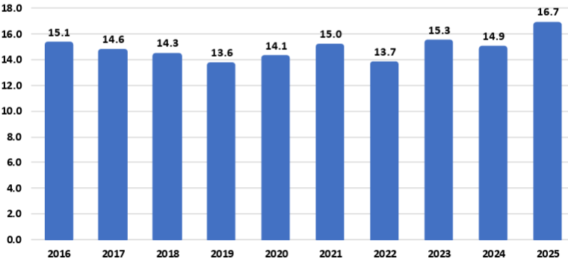
Source: USDA
For example:
The National Corn Growers Association (NCGA) is intensifying its call for action from Congress and the administration after the U.S Department of Agriculture’s latest World Agriculture and Supply and Demand Estimates report projected a record 16.7-billion-bushel corn crop this year, further threatening the livelihood of farmers already facing record-low corn prices.
“Corn growers are already marketing their corn for extremely low corn prices, and this massive projected corn supply without market-based solutions to increasing corn demand is already causing corn prices to fall further,” said Illinois farmer and NCGA President Kenneth Hartman Jr. “Because we need markets fast for this supply, we are redoubling and intensifying our call for Congress to pass pending E15 legislation that will allow for year-round consumer access to higher blends of ethanol and for the Trump administration to quickly broker deals that will open new foreign markets for corn.”
Today’s WASDE report projects average corn yields of 188.8 bushels per acre for 2025, for an overall crop of 16.7 billion bushels. If the projections prove accurate, this year’s crop will be the largest on record by far: 1.4 billion bushels above the current production record set in 2023, a 9.1 percent increase.
An immediate boost to demand would be the passage of legislation authorizing year-round consumer access to 15 percent ethanol blend, or E15. This solution comes at no cost to consumers, requires no additional infrastructure developments and would generate demand for an additional 457 million bushels of corn, according to NCGA estimates.
NCGA is also pushing the administration to quickly broker additional deals with other countries and finalize details on deals already announced. For example, India, Vietnam and Kenya are all strategically important markets to U.S corn growers.
Sen. Joni Ernst, R-Iowa, on July 31 introduced the Ethanol for America Act, a bill that aims to make it easier for Americans to fuel their vehicles with domestically produced E15. Companion legislation was introduced the following day by Rep. Adrian Smith, R-Neb.
The legislation would eliminate unnecessary barriers to E15 by requiring the U.S EPA to finalize rulemaking from 2021 to make the E15 fuel label clearer and more consumer oriented. It would also confirm the compatibility of E15 with existing underground fuel storage and dispensing equipment.
Currently, fuel dispensers offering E15 must feature a label designed to alert customers to the appropriate and lawful use of the fuel. The proposed rule, issued in January 2021, co-proposes to either modify the E15 label or remove the label requirement entirely. The EPA opened a 90-day public comment period on the proposal but has failed to take final action on the rulemaking.
Following its introduction, the Senate bill, S. 2591, was referred to by the Senate Committee on Environment and Public Works. To date, Sens. Amy Klobuchar, D-Minn.; Deb Fischer, R-Neb.; Chuck Grassley, R-Iowa; Tammy Duckworth, D-Ill.; and Richard Durbin, D-Ill., have signed on to cosponsor the bill. The House bill, H.R. 4864, was referred to the House Committee on Energy and Commerce. Reps. Nikki Budzinski, D-Ill.; Dusty Johnson, R-S.D.; Tracey Mann, R-Kan.; Derek Schmidt, R-Kan.; Mike Flood, R-Neb.; Randy Feenstra, R-Iowa; and Brad Finstad, R-Minn., are cosponsoring the House bill.

Vietnam Opening Market to Ethanol
To boost ethanol imports from the U.S tenfold to approximately 290 million gallons, the Vietnam Biofuel Association has proposed that the government swiftly implement a nationwide E10 biofuel gasoline program.
The Vietnam Biofuel Association recently submitted a document to the Domestic Market Management and Development Department (under the Ministry of Industry and Trade), addressing several issues related to the import tax on 99 percent ethanol used for biofuel blending, as well as the broader context of tariff negotiations and trade relations between Vietnam and the United States.
According to the association, the import tax on 99 percent ethanol - a type specifically used in biofuel gasoline blending - has continuously decreased from 15 percent to 12 percent, then 10 percent, and most recently to 5 percent. These reductions fall within the broader trade policy framework between Vietnam and the U.S
Petrolimex and PVOIL, Vietnam’s two largest fuel distributors and retailers, launched the country’s first commercial trials of gasoline blended with 10 percent ethanol (E10) in three major cities last week. A total of 42 fuel stations in Hanoi, Ho Chi Minh City and Hai Phong began selling E10 RON95 gasoline as part of the trial that follows the Government of Vietnam’s recent announcement of a nationwide E10 mandate to begin in January.
“The U.S Grains & BioProducts Council (USGBC) and its members and partners commend Petrolimex, PVOIL and the Government of Vietnam for advancing the use of fuel ethanol in Vietnam as a means to reduce harmful emissions, bolster fuel security and further stimulate rural economies,” said Ryan LeGrand, USGBC President and CEO. “This month’s rollout of E10 gasoline at retail stations is a massive step toward decarbonizing Vietnam’s transportation sector and a new potential partner for the U.S ethanol industry and the American farmer.”
In 2018, Vietnam implemented an E5 mandate for its RON92 grade of gasoline, one of two gasoline grades widely used throughout the country. The Government of Vietnam’s decision to expand and migrate the country’s ethanol policy in 2026 to E10 and all grades of gasoline, including the more widely used RON95 grade, will help the Vietnamese fuel industry amplify the environmental and economic benefits of fuel ethanol use which augment Vietnam’s policy objectives.
Vietnam’s gasoline consumption surpassed 2.8 billion gallons in 2024, increasing 8.1 percent from 2023 consumption levels. A nationwide E10 mandate will create a total fuel ethanol demand of 280 to 300 million gallons per year, depending on gasoline demand.

USDA Land Value Report
The United States farm real estate value, a measurement of the value of all land and buildings on farms, averaged $4,350 per acre for 2025, up $180 per acre (4.3 percent) from 2024. The United States cropland value averaged $5,830 per acre, an increase of $260 per acre (4.7 percent) from the previous year. The United States pasture value averaged $1,920 per acre, an increase of $90 per acre (4.9 percent) from 2024.

Average Farm Real Estate Value (Dollars)
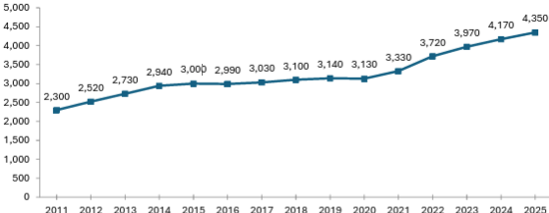
Source: USDA NASS

Farm Real Estate Value by State
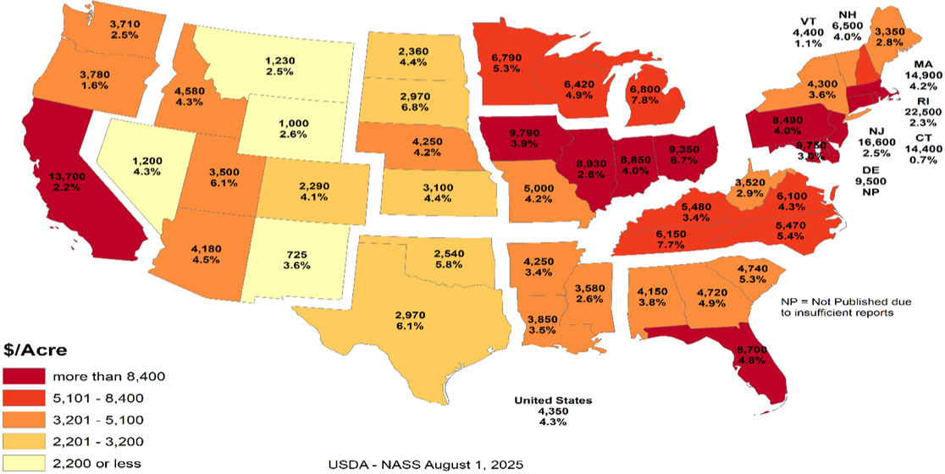
Like overall farm real estate values, average U.S cropland values rose to record levels in 2025, reaching $5,830 per acre. This marks a 4.7 percent increase over 2024, nearly identical to the previous year’s growth but slower than the sharper increases earlier in the decade. In dollar terms, cropland values rose by $260 per acre year over year. Regional patterns remain consistent with broader farmland trends, with California and Northeastern states reporting the highest average cropland values. These are followed by much of the Midwest and Florida, the latter reflecting strong specialty crop production and ongoing residential development pressures. The top three states in percentage growth were Utah (9.7 percent), Michigan (8.2 percent) and Tennessee (7.8 percent). Notably, no states recorded a decline in cropland values.

Average Cropland Value (Dollars)
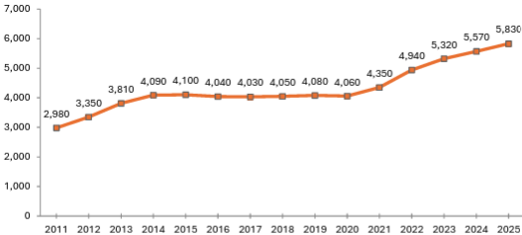
Source: USDA NASS

Cropland Value by State
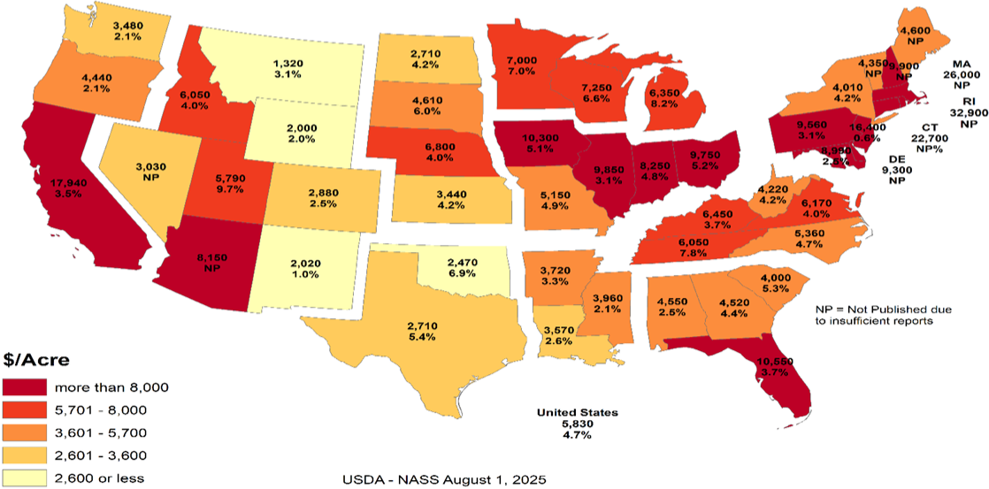
U.S pastureland values continued their upward trend in 2025, rising to $1,920 per acre, a 5 percent increase over 2024. This growth is nearly in line with last year’s 5.2 percent gain but remains below the 6.7 percent increase in 2023 and the sharp 11 percent jump in 2022, which followed nearly a decade of stagnant values.
Unlike cropland and overall farm real estate, pastureland values are highest along the East Coast and mid-South, where development pressures, land scarcity and lifestyle demand contribute to elevated prices. In contrast, Western and Plains states report lower average values, partly due to lower land productivity and the prevalence of federally owned grazeable land accessed through grazing permits, which reduces market-based competition. In densely populated Eastern states, fragmentation of land and rising competition for open space (whether for grazing, recreation or rural living) continue to drive up per-acre costs for the limited private pastureland available.

Average Pasture Value (Dollars)
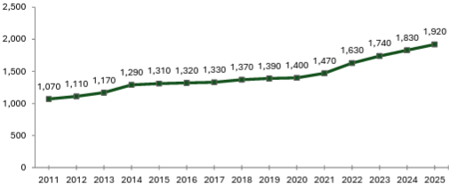
Source: USDA NASS

Pasture Value by State
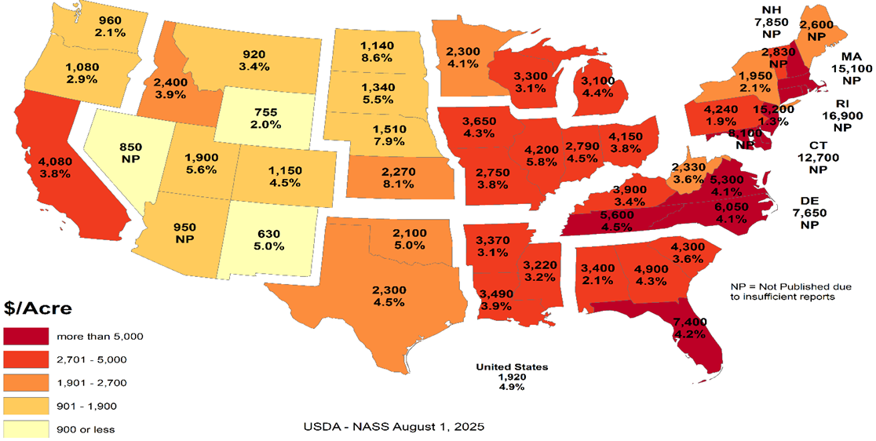

Cash Rents
American Farm Bureau summarized the USDA NASS cash rent survey.
NASS also released data on cash rents, which tend to lag changes in land values and commodity prices due to early-season lease negotiations. While the reported figures reflect past agreements, they often serve as important benchmarks for future producer-landlord negotiations, especially in areas with variable rent structures. Average U.S cropland rent increased to $161 per acre in 2025, a modest 0.6 percent rise over 2024 — just $1 per acre. Irrigated cropland rents declined by 0.4 percent to $244 per acre, while non-irrigated rents rose 0.7 percent to $147 per acre. Pastureland cash rents remained unchanged at $15.50 per acre.
Despite minimal national movement, pressures on open land for solar development, suburban expansion and recreation continue to support rental rate growth in select areas, particularly where demand for working land is layered with lifestyle or energy investment interest. Increased telework continues to pull buyers and lessees into rural areas, intensifying local competition for land in certain high-amenity or fast-growing regions.
While earlier rent increases were tied closely to the 2021–2022 commodity price boom, today’s changes are more uneven, shaped by regional water constraints and shifting cropping patterns. In some areas, recent federal disaster assistance may have tempered pressure to renegotiate downward, even as commodity prices weaken and input costs remain high.

Cropland Cash Rent Value by State (Percent Change)
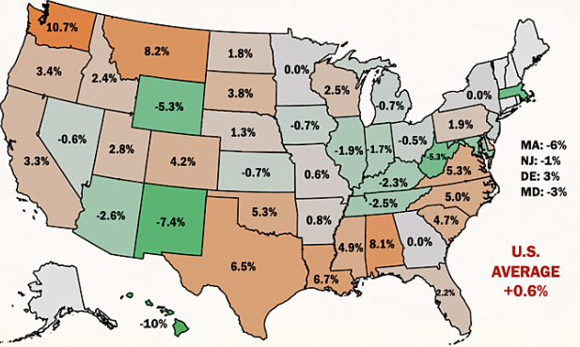
Source: American Farm Bureau, USDA NASS
Washington and Montana led the country in cropland cash rent growth, up 10.7 percent and 8.2 percent, respectively, followed by Alabama at 8.1 percent. Meanwhile, cropland rents in Hawaii, New Mexico, Wyoming, West Virginia and Massachusetts declined by more than 5 percent, likely due to a mix of stabilized drought conditions, changing land use priorities and rebalancing after years of sharp growth.
By value, the most expensive cropland rents remain in states with high-value specialty crops, such as California ($346/acre), Arizona ($334/acre) and Hawaii ($295/acre), often driven by contracts tied to irrigation infrastructure and water rights. Iowa, Illinois, Indiana and Washington round out the next tier of high-rent states, reflecting both row crop concentration and specialty crop presence. Water access and cost continue to be major drivers of both land value and rental rates across the Western U.S
Margins for producers who rely heavily on rented land remain precarious, especially as revenue potentially slips while fixed costs (including rents) remain elevated or inflexible. Beginning farmers and those without land equity are especially exposed, facing steep barriers to accessing operating credit. In a year where net farm income is forecasted to decline without ad hoc support, even modest increases in rental rates can have outsized financial consequences.

Conclusion
Rural land values are experiencing a price bubble. In many of the Corn Belt states the cropland value continues to increase while the cash rent decreases. The values represent the impact of government land-based farm programs and ad hoc payment that could go to landowners. The government incentives to buy land have diminished the link between land values and real agricultural value. The result is farmers who rent land are increasingly in financial distress. As farmers exit the market, the disconnect between the land prices and cash rents will increase.
What the government gives it can take away. The Democrat party can win without the farm vote. Their messaging is trending away from “preserving family farmers” to “bashing Big Ag.” If rural land prices start declining, the floor is real agricultural value. For example, Illinois cash rent for cropland is $264 per acre. Farmdoc crop budget indicates that if a cash rent farmer needs $100 profit per acre to survive, the cash rent should be approximately $133 per acre or a decrease of approximately half. Assuming a 5 percent rate of return, the real agricultural value for cropland in Illinois is $2,660 per acre versus $9,850 per acre.
The other concern is that many of the new land buyers are investors. The investors are helping to drive land prices higher. When land values decrease, will the investors sit tight or take a profit? The investors do not have the same emotional attachment to the land. Farmers who want to own their own land act as a “put” under the land market. The good news is the farmers currently have low debt levels. This means the farmers have access to cash to buy land. The unknown is if the farmers are making a good investment or trying to catch a falling knife.

Cropland Cash Rent Value by State
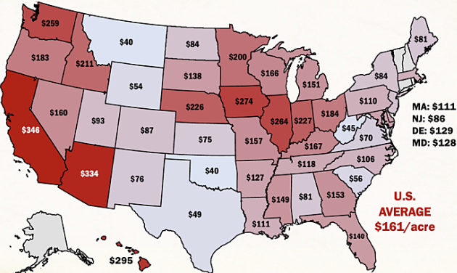
Source: American Farm Bureau, USDA NASS

Farmer Sediment
The Purdue University-CME Group Ag Economy Barometer index declined for the second month in a row. The July index fell 11 points below June’s reading and was fueled by U.S farmers’ weaker perceptions regarding both current conditions and their expectations for the future. The July Current Conditions Index fell 17 points while the Future Expectations Index declined 7 points, both compared to a month earlier. Weaker income prospects in 2025 were largely responsible for farmers’ weaker appraisal of current conditions. Although all three principal farmer sentiment indices were lower in July than a month earlier, producer sentiment remains much more positive than at this time last year, with nearly three-quarters of July’s survey respondents reporting that the U.S is headed “in the right direction.” The July barometer survey took place from July 7-11, 2025.
Concerns about weak income prospects in 2025 were evident in the July survey as the Farm Financial Performance Index fell 14 points compared to a month earlier. This month’s decline left the index at a reading of 90, indicating that more farmers expect weaker rather than stronger income in 2025 compared to 2024. Weakening crop prices are eroding income prospects. For example, in the Eastern Corn Belt, bids for fall harvest delivery of corn and soybeans were 7 percent and 3 percent lower during the July survey week, respectively, than just 4 weeks earlier. In turn, the decline in farmers’ income prospects helped push the Farm Capital Investment Index down 7 points in July to a reading of 53.

Farm Financial Performance Index
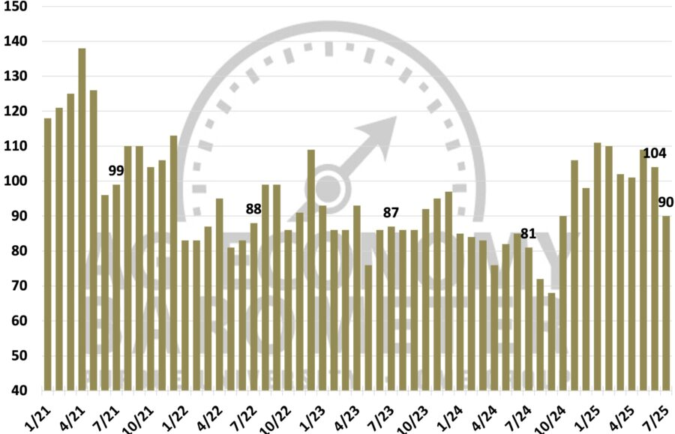
Source: Purdue/CME Group Ag Economy Barometer
Unsurprisingly, a weaker income outlook led to a softer outlook for farmland values in the upcoming year. The Short-Term Farmland Value Expectations Index dipped 5 points below a month earlier. This month’s reading of 115 also left the index 3 points lower than a year earlier and 10 points below two years ago. The farmland index’s weakness was attributable to a small shift among respondents away from expecting values to rise to looking for weakening values in the upcoming year, while the percentage expecting values to hold steady rose just one point to 57 percent. With farmland leasing discussions for next year underway between farmers and landowners, this month’s survey included a question regarding crop producers’ expectations for farmland cash rental rates in 2026. Despite weakening crop income prospects, nearly three-fourths (73 percent) of respondents said they expect cash rental rates in 2026 to remain about the same, with just 11 percent of crop producers indicating they expect rental rates to decline.
One supporting factor for both farmland values and farmland cash rental rates could be producers’ expectations regarding the farm income safety net provided by U.S farm programs. In this month’s survey, 31 percent of respondents said they expect the safety net in the 2025 Farm Bill to be stronger than in the previous Farm Bill.
U.S farmers in July were somewhat more optimistic about future agricultural trade prospects than a month earlier. This month, 43 percent of respondents said they expect agricultural exports to increase in the upcoming five years, up from 41 percent a month earlier. Fewer producers said they are looking for exports to decline, dropping to 13 percent of respondents, down from 16 percent who felt that way in June. In a related question, 64 percent of this month’s survey respondents said they think it likely that new foreign export markets will open to American agricultural goods in the next five years. To further gauge U.S farmers’ outlook regarding trade and policy, this month’s survey included the following question: “Would you say things in the United States today are generally headed in the right direction or on the wrong track?” Seventy-four percent of respondents said the U.S is headed in the “right direction.”
U.S farmers’ sentiment declined in July as weaker farm income prospects dimmed producers’ view of current conditions and their future expectations. Despite a weaker crop income outlook, just 11 percent of crop producers said they expect farmland cash rental rates to decline, with a majority reporting that they expect rental rates to stay about the same. Helping to support producers’ farmland value and rental rate outlook is farmers’ expectation for a stronger farm income safety net, with nearly one-third (31 percent) of U.S producers saying they expect the 2025 Farm Bill to provide a stronger safety net than the previous Farm Bill. Producers in July were somewhat more optimistic about U.S agricultural trade prospects than in June, while nearly three-fourths (74 percent) of U.S farmers responding to the survey reported that they feel that things in the U.S are headed “in the right direction.”

Bunge Buys IFF Crush Division
As part of its second quarter results disclosure, International Flavors & Fragrances Inc. announced that it has entered into a definitive agreement to divest its soybean crush, concentrates, and lecithin business to Bunge Global S.A. The transaction includes operations that generated approximately $240 million in revenue in 2024 and employs around 250 people globally. The sale aligns with IFF’s strategy to strengthen its portfolio and supports the ongoing evaluation of strategic alternatives for its Food Ingredients segment, with a focus on maximizing shareholder value.

Greenhouse Gas Phase 3 Standards do not Apply to Human Health
The industry has an aftertreatment system for EPA's 2007 and 2010 Heavy-Duty Highway Engines and Vehicle emissions reduction regulations, which set standards for not only NOx but also particulate matter (PM). It also mandated the use of advanced emission control technologies like selective catalytic reduction (SCR) and diesel particulate filters. "Completely separate," said North American Council for Freight Efficiency Executive Director Mike Roeth. "Aftertreatment is not a direct GHG solution. We tend to call NOx and PM pollutant emissions, and they are directly attached to human health; breathing in these in the air... Carbon/GHG is different in that it affects climate, encouraging our more frequent and harsher weather events causing other health concerns."
Daimler Truck North America (DTNA) noted in a statement to Commercial Carrier Journal (CCJ) that the proposal does not modify EPA's existing requirements for criteria pollutants, including NOx and PM. NOx and PM standards remain in place, and they continue to be enforced independently of any changes to GHG regulations. "Selective Catalytic Reduction (SCR) systems, Diesel Exhaust Fluid (DEF), and aftertreatment technologies are essential components designed to reduce nitrogen oxides (NOx) regulated under the EPA's Clean Air Act," added Paccar companies Kenworth and Peterbilt. "The current aftertreatment systems related to NOx are still required to meet EPA and CARB standards and are independent of greenhouse gas (GHG) specific mandates."
Covered in the Endangerment Finding is nitrous oxide (N2O). NOx is shorthand for nitric oxide (NO) and nitrogen dioxide (NO2), the nitrogen oxides most relevant for air pollution. NOx itself is not considered a greenhouse gas; rather it plays a role in the formation of ozone, a naturally occurring greenhouse gas. Thus, NOx is not a greenhouse gas and the aftertreatment system, including DEF, would not be affected by this pending regulatory change.
However, EPA Administrator Lee Zeldin said in March his office intends to revisit portions of the Biden-era Clean Trucks Plan, which includes the 2022 Heavy-Duty NOx rule – a standard that includes new, more stringent emissions standards that cover a wider range of heavy-duty engine operating conditions and requires these more stringent emissions standards to be met for a longer period of time.

DEF Guidance Clarification
Starting in the early 2010s, regulations required all new on-road diesel vehicles, tractors, trucks, buses, ships, locomotives, gas turbines and construction equipment, to install additional technology to reduce nitrogen oxide emissions, a byproduct of diesel. Almost all commercial diesel transportation and equipment today has Selective Catalytic Reduction (SCR) technology that runs on DEF.
According to an EPA release, "EPA issued clear guidance urging engine and equipment manufacturers to revise DEF system software in existing vehicles and equipment to prevent these sudden shutdowns, giving operators more time to repair faults without impacting productivity or safety."
The EPA provided a chart showing derate timing for heavy duty trucks will be extended from a 5-mph limitation after just four hours' worth of a system fault to a three-stage derate:
- 15 percent torque reduction at 650 miles / 10 hours
- 30 percent torque reduction then at 4,200 miles / 80 hours
- and a final-stage derate to 25 mph at 8,400 miles / 160 hours
"In addition to providing certainty to manufacturers about how EPA wants this issue resolved, the agency is not requiring separate approvals beyond that provided in EPA’s guidance," the release said. "This ensures that bureaucratic steps do not delay manufacturers’ ability to put solutions into the field.”
Before the new EPA DEF guidance, a farmer had four hours before the vehicle or equipment stopped operating, leaving the farmer stranded. EPA’s new guidance to engine manufacturers will reduce derating, an automatic trigger forcing the engine to operate at a reduced capacity far below its capability and increase the amount of time operators must secure DEF and refuel.
Previously, farmers and truckers faced rapid engine slowdown to 5 mph within just four hours of a sensor alert. Under EPA’s new guidance for heavy-duty trucks, for example, after a fault is detected, only a warning light appears for 650 miles or 10 hours. Most significantly, there is no performance impact for at least one workday. Then, the engine only mildly derates by 15 percent, but this does not limit speed, allowing trucks to operate normally for up to 4,200 miles or two work weeks. Only after about four work weeks does speed drop to 25 mph until repairs are made. Most operators are expected to fix issues well before reaching this limit. Moving forward for farmers, non-road equipment will not experience an impact for the first 36 hours.
The ruling represents a major step up from the status quo by giving operators significantly more time to address faults before experiencing severe engine or speed limitations, which will improve their ability to complete daily operations and reduce downtime.
The revised DEF guidance is estimated to reduce farming expenses by $727 million annually. With fewer disruptions, reduced costs for emergency towing, repairs, rentals, DEF deliveries and inventories, producers will have greater operational and financial control.

Truck Manufacturers Sue CARB/California
Four of America’s top truck makers have officially filed a lawsuit in the U.S District Court for the Eastern District of California challenging the Clean Truck Partnership (CTP) agreement signed with the California Air Resources Board in 2023. CARB has argued since the Congressional rollback of its Advanced Clean Trucks and Omnibus Low-NOx rules earlier this summer that despite the federal disapproval of the regulations, the CTP is still binding.
Cummins, Daimler Trucks North America, Hino, Isuzu, then-Navistar, Paccar, the Truck and Engine Manufacturers Association, and Volvo Group North America in July 2023 were among 11 signers of the CTP, an agreement with CARB that pledged truck and engine manufacturers will meet California’s vehicle standards and required the sale and adoption of zero-emission vehicle (ZEV) technology.
The OEMs said in the lawsuit that despite the Congressional Review Acts passed this year preempting California’s emissions standards, the state “continues to demand compliance with its heavy-duty emissions standards, and it has threatened OEMs that design, develop, manufacture and sell heavy-duty vehicles and engines ... with civil sanctions and unfavorable regulatory treatment if the OEMs refuse to comply with the state’s unlawful standards, while also taking measures to insulate itself from lawful challenges to those standards.”
Senior Clean Vehicles Advocate for the Natural Resources Defense Council Guillermo Ortiz called the lawsuit, "a cynical reversal of course. These companies helped negotiate the Clean Truck Partnership to secure regulatory certainty. Now they’re trying to dismantle the very deal they shaped -- injecting instability into a market they claim to lead," he said. "This is bad faith, plain and simple, and it raises questions about whether these manufacturers are serious about their ability to deliver clean trucks to the global stage."
The OEMs said the U.S Department of Justice has sent them Cease & Desist letters stating that California’s enforcement of its regulations “is contrary to federal law” and directed the truck makers “to immediately cease and desist compliance with California’s preempted and unlawful mandates.”
This has left the OEMs “caught in the crossfire,” they said, as “California demands that OEMs follow preempted laws; the United States maintains such laws are illegal and orders OEMs to disregard them. This situation is not tenable.”
As such, the lawsuit aims to clarify the OEMs’ legal obligations under federal and state law and to block California from enforcing regulations that are preempted by federal law. Given the inconsistencies between federal and California regulatory requirements for emissions, truck and engine makers and their trade associations in 2023 petitioned CARB for relief from the state’s “infeasible regulatory requirements,” which resulted in the CTP, the lawsuit added. Now, according to the OEMs, “California seeks to use the Clean Truck Partnership, which was intended to harmonize compliance with state and federal law, to compel an entire industry to follow California emissions standards that are now in conflict with federal law, and which have been expressly preempted by federal law.” They added that the state is disregarding the CTP’s “plain language,” which “states that manufacturers are obligated to follow CARB’s emissions regulations ‘regardless of the outcome of any litigation challenging … those regulations, or CARB’s overall authority to implement those regulations,’ not federal legislative action taken to invalidate them.”
The regulatory back-and-forth between the federal government and California/CARB has put OEMs “in an impossible position,” they said in the lawsuit. “As a result, the OEMs are subject to two sovereigns whose regulatory requirements are irreconcilable and who are openly hostile to one another. Each wields a hammer to enforce its will on industry, leaving OEMs -- who simply seek to sell heavy-duty trucks in compliance with the law -- unable to plan with the necessary certainty and clarity where their products need to be certified for sale and by which regulatory authority.”
California, citing the CTP, has contended that in order for OEMs to legally sell trucks in the state, they must obtain certification from CARB. Yet the OEMs said this process “takes months,” adding that they “need to know within a matter of weeks whether they must obtain a model year 2026 certification from CARB in order to lawfully sell their products in California and other opt-in states, which together represent approximately 25 percent of the national market for new vehicle registrations for heavy-duty vehicles.”
In filing the lawsuit, the truck makers said they are looking for “declaratory and injunctive relief with the goal of clarifying and establishing the regulatory obligations that they must follow to lawfully offer products for sale in California and the various opt-in states, and to prevent California officials from violating their constitutional rights,” adding that “an expeditious decision is essential.”
The OEMs’ lawsuit joins another suit brought by the Western States Trucking Association that challenged CARB’s authority to enforce the CTP following the federal preemption of the regulations.

Ambassador Jamieson Greer: Why We Remade the Global Order
The following op-ed provides the foreign policy vision of the Trump Administration. On the 200-day mark of the second Trump administration, United States Trade Representative Jamieson Greer published an op-ed in The New York Times explaining how President Trump’s trade policy is remaking the international economic order to reduce our trade deficit and deliver lasting benefits for American workers and industries.
The full text of the op-ed is below:
It must be an unwritten rule that international economic orders emerge at stately hotels. In 1944, as World War II raged, Allied representatives gathered at a picturesque New Hampshire resort named Bretton Woods to discuss how to establish a postwar economic order to restore the sensible flow of trade in a fractured world.
Although the resulting Bretton Woods system ended in 1976, its legacy lives on. Our current, nameless global order, which is dominated by the World Trade Organization and is notionally designed to pursue economic efficiency and regulate the trade policies of its 166 member countries, is untenable and unsustainable. The United States has paid for the system with the loss of industrial jobs and economic security, other countries have been unable to make needed reforms, and the biggest winner has been China, with its state-owned enterprises and five-year plans. Unsurprisingly, the past decade has seen significant international and bipartisan American frustration at the system’s failure to adapt to meet the essential interests of sovereign nations.
Now, reform is at hand. Last week at his Turnberry resort on the Scottish coast, President Trump and the European Commission president, Ursula von der Leyen, concluded a historic agreement — one that is fair, balanced and oriented toward serving concrete national interests rather than vague aspirations of multilateral institutions. Indeed, by using a mix of tariffs and deals for foreign market access and investment, the United States has laid the foundation for a new global trading order.
The previous system rejected tariffs as a legitimate tool of public policy, meaning that the United States sacrificed tariff protection for critical manufacturing and other sectors. Over the past three decades, the United States slashed barriers to our market to allow vast inflows of foreign goods, services, labor and capital. At the same time, other countries kept their markets closed to our goods and deployed a suite of policies — such as subsidies, wage suppression, lax labor and environmental standards, regulatory distortions and currency manipulation — to artificially boost exports to the United States. This approach made the United States and a handful of other economies the consumers of last resort for countries pursuing beggar-thy-neighbor economic policies.
Our trading partners were adept at this game, and elites on Wall Street and in Washington were all too happy to cash in on the global arbitrage by moving production abroad. The net result? The bulk of global manufacturing shifted to jurisdictions such as China, Vietnam and Mexico where companies could exploit vulnerable workers or benefit from expansive state support while the United States ran up what in absolute terms is the highest trade deficit in the history of the world. This led to extensive and well-documented losses in U.S industrial capacity and employment as well as reliance on our adversaries for critical supply chains.
We subordinated our country’s economic and national security imperatives to a lowest common denominator of global consensus. This approach harmed American workers, their families and communities by undermining a manufacturing sector that creates high-wage jobs, fosters innovation and catalyzes investment across the economy.
What began at Bretton Woods as a necessary effort to rebuild a global trade system shattered by war evolved, over nine rounds of trade negotiations, into something unrecognizable. The measured guidelines for commerce developed in the Kennedy and Tokyo Rounds gave way to our recent experiment in global hyper-integration, embodied in the Uruguay Round, which concluded in 1994 and established the W.T.O.
We are now witnessing the Trump Round. On April 2, President Trump announced tariffs to address the national emergency posed by the trade deficit. The intense bilateral negotiations that followed were held in diverse locations across the world: Washington, Geneva, Jeju Island, Paris, London, Stockholm and, of course, Turnberry. Our trading partners had never before shown such interest in opening their markets to the United States, aligning on matters of economic and national security, and rebalancing trade in a more sustainable direction. In a few short months, the United States secured more foreign market access than it had in years of fruitless W.T.O negotiations.
Reversing decades of harmful policy that weakened our manufacturing capacity and work force will take time and coordinated effort across the public and private sectors. But keeping the status quo would only accelerate the dangerous trajectory of deindustrialization. We require a generational project to re-industrialize America, and time is short.
When I joined a critical mass of my fellow trade ministers in June at a meeting of the Organization for Economic Cooperation and Development in Paris, I was struck by how many voiced serious concerns about the danger of macroeconomic imbalances, the threat of nonmarket practices and the sclerotic state of the global trading system — the same issues President Trump has raised for years and now taken emergency action to address. What was long dismissed as heresy by the free-trade fundamentalists in Brussels, Geneva and Washington is now becoming conventional wisdom.
In announcing the U.S-European Union deal last week, President von der Leyen echoed the call to refashion global trade to adapt to economic and political realities. She explained to reporters that the trans-Atlantic economic relationship needed “rebalancing” to ensure that it could be “more sustainable.” Such recognition is reinforced by additional deals with Britain, Cambodia, Indonesia, Japan, Malaysia, Pakistan, the Philippines, South Korea, Thailand and Vietnam, which make up almost 40 percent of U.S trade, according to my office’s figures. Other countries with large trade surpluses with the United States are subject to generally higher tariffs. The new economic order, solidified at Turnberry, is emerging in real time.
The results are astounding. Every year for 40 years, the Office of the U.S Trade Representative has produced a detailed report called the National Trade Estimate chronicling various barriers faced by U.S companies, including high tariffs, requirements to produce goods in the countries where the companies want to do business, and restrictions on agricultural products contrary to scientific consensus. In the past, the only significant way the United States could remove these barriers (if at all) was by giving away the tariffs defending our manufacturing sector. President Trump has flipped the script on this: Now, we are systematically eliminating these barriers abroad while ensuring sufficient tariff protection at home.
Indonesia is lowering 99.3 percent of its tariffs on imports from the United States and eliminating a slew of longstanding non-tariff barriers, while accepting a 19 percent tariff on exports to the United States. South Korea is accepting U.S auto standards along with a 15 percent tariff. Vietnam pledged to lower all of its tariffs and barriers in exchange for a 20 percent rate. Most countries we are negotiating with have also agreed to cooperate on economic security to ensure the safety and reliability of our critical supply chains.
Countries are also committing to upgrade and better enforce their labor standards, tackling arbitrages that have put American workers and producers at a disadvantage. Multiple countries will join the United States (along with the E.U., Mexico and Canada) in banning the importation of goods made with forced labor. Eliminating global slavery was a longstanding goal of advocates and policymakers, but it was the leverage of President Trump’s tariffs that finally made it possible to unlock meaningful progress.
Similarly, countries are agreeing to improve resource efficiency and enforcement of environmental laws, including in the most problematic sectors, such as illegal logging, illegal fishing and the illegal wildlife trade. The international trade system should not force Americans to compete with those who use our responsible capitalism against us as a competitive advantage.
Importantly, these commitments are actionable, and the United States will enforce them. Rather than the drawn-out dispute settlement process favored by the old guard of trade bureaucrats, the new U.S approach is to closely monitor implementation of the deals and swiftly reimpose a higher tariff rate for noncompliance if needed. President Trump uniquely recognizes that the privilege of selling into the world’s most lucrative consumer market is a mighty carrot. And a tariff is a formidable stick.
At the World Trade Organization, enacting changes to trade rules requires total consensus among nations. In fact, the last attempt at serious reform, known as the Doha Round, failed because protectionist nations refused to take down their trade barriers to the United States. Moreover, our adversaries relish blocking reform. They prefer a status quo that feeds an exploding U.S trade deficit, sapping this nation of the industrial might that made it, and keeps it, a superpower.
But the rules of international trade cannot be a suicide pact. By imposing tariffs to rebalance the trade deficit and negotiating significant reforms that form the basis of a new international system, the United States has shown bold leadership to address what policymakers long considered intractable problems.
Many of these deals also come with significant investment commitments into U.S productive capacity, such as $600 billion in the case of the European Union and $350 billion by South Korea. These investments — 10 times larger than the inflation-adjusted value of the Marshall Plan that rebuilt Europe after World War II — will accelerate U.S reindustrialization. South Korea will help reinvigorate the American shipbuilding industry, which has atrophied in the face of nonmarket competition. These types of investments are on top of purchase commitments that cumulatively account for almost $1 trillion of American energy, agriculture, defense and industrial products. This demand for American goods and ready access to capital will allow American manufacturing to reassert leadership across strategic sectors where we have fallen behind.
Skeptics point out that tariffs, although once a fixture of American economic policy, have not been used this extensively for generations. But we now have data showing that the failure to use tariffs or similar protections created an economy that was heavy on finance and consulting fees and low on the lasting wealth and security that come from making things. Even among those who agree with that diagnosis, some say the president’s remedy is too strong or was administered too hastily, or that the tariffs will be too disruptive in the short term. This is not the time to debate how many angels can dance on the head of a pin. This is an emergency. We know what the problem is and we know how to address it. There is no time to waste.
President Trump has already shown that he can implement tariffs and other economic tools to reshape supply chains and reinvigorate manufacturing. When he deployed sweeping tariffs in his first term, not only did the sky not fall as pundits predicted, but inflation actually went down. And now that he is imposing tariffs even more broadly, inflation remains in check. A long-term problem won’t be fixed overnight, and the process may not always be smooth, but the situation demands strong and resolute action to strengthen the U.S industrial base.
It took over 50 years from that first meeting at Bretton Woods until the creation of the W.T.O. It has been 30 years since. Fewer than 130 days from the beginning of the Trump Round, the Turnberry system is by no means complete, but its construction is well underway.

Stagflation Discussion
Stagflation talk has taken center stage. It should be remembered that stagflation in the 1970s was driven by crude oil prices increasing from $3.56 per barrel in August 1973 to $10.11 per barrel in January 1974 to $14.85 per barrel in January 1979 to $39.50 per barrel in May 1980. In less than seven years crude oil price increased by over 1,100 percent. By comparison, the current crude oil price is approximately half the May 2022 price. With almost every country expanding energy production, lower energy prices could occur.
According to the prolonged price decrease in crude oil and natural gas, inflation numbers will be below macro-economic models. This is because energy is incredibly important as it impacts inflation numbers directly, such as fuel and as a feedstock in petrochemicals, and indirectly, such as an increased cost that a manufacturer and business must recoup. Energy costs impact input prices for production, and every other stage required to reach the consumer with each cost increase being pushed to the next level. The cumulative impact of higher energy prices on the consumer tends to be understated by macro-economic models.
One inflationary outcome from lower energy prices is discretionary income increasing, which allows for more spending. The other outcome is the producer price index will show a decline with retail sales prices staying firm and retailers performing better than if it was still a higher energy cost environment. Any economic downturn will force retailers to lower prices to move products.
The inflationary impact of the massive increase in the money supply has worked its way through the economy, resulting in a natural slowdown. It is difficult to have runaway inflation with lower energy prices, and a weak housing market.
During the last trade war, the rate of inflation decreased. It is not a forgone conclusion that the rate of inflation is going to increase. The consumer price index increased a seasonally adjusted 0.2 percent for the month and 2.7 percent on a 12-month basis, the Bureau of Labor Statistics reported. That compared with the respective Dow Jones estimates for 0.2 percent and 2.8 percent.
Excluding food and energy, the core CPI increased 0.3 percent for the month and 3.1 percent from a year ago, compared with the forecasts for 0.3 percent and 3 percent. Federal Reserve officials generally consider core inflation to be a better reading for longer-term trends. The monthly core rate was the biggest increase since January while the annual rate was the highest since February.
Tariff-sensitive new vehicle prices also were unchanged. For now, automakers are choosing to keep market share.
A 0.2 percent increase in shelter costs drove much of the rise in the index, while food prices were flat and energy fell 1.1 percent, the BLS said. U.S housing market now 508,715 more home sellers than homebuyers. With the current housing market experiencing pain, it is easier to envision lower prices not higher prices.

U.S Consumer Price Index (Annual Change)
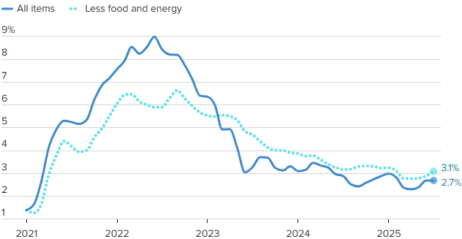
Crude Oil $120 per barrel
Source: BLS, CNBC

Estimated Number of Homebuyers and Sellers
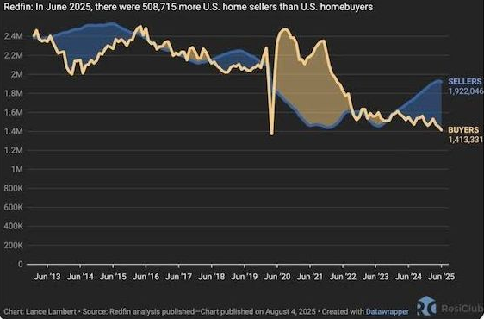

Mid-America Manufacturing Slumps for July
After six straight months of above growth neutral readings, the Creighton University Mid-America Business Conditions Index, a leading economic indicator for the nine-state region stretching from Minnesota to Arkansas, sank below 50.0 growth neutral threshold for July.

Overall Index
The Business Conditions Index, which uses the identical methodology as the national Institute for Supply Management (ISM) and ranges between 0 and 100 with 50.0 representing growth neutral, declined to 49.4 for July from 50.7 in June.
“Creighton’s latest survey continues to reflect job losses across the region, accompanied by elevated wholesale inflation,” said Ernie Goss, PhD, Director of Creighton University’s Economic Forecasting Group and the Jack A. MacAllister Chair in Regional Economics in the Heider College of Business. “Supply managers expressed growing concern that rising tariffs could further accelerate inflationary pressures. Despite these concerns, only 6.7 percent of surveyed supply managers reported shifting purchases from international to domestic suppliers in response to the tariffs.”

Employment
The July employment index fell to 45.4 from 49.4 in June, marking the fourth consecutive month below the growth-neutral threshold of 50. This sustained weakness reflects ongoing labor market challenges in the regional manufacturing sector.
“The Creighton survey has now recorded six straight months of job losses across the nine-state Mid-America region,” said Goss. “While employment rose in the first quarter—driven by increased production ahead of anticipated tariff impacts—the last four months have signaled a return to regional manufacturing job declines,” said Goss.
U.S Bureau of Labor Statistics data show that the region shed 12,900 (-0.9 percent) manufacturing jobs over the past 12 months. The U.S lost 89,000 (-0.7 percent) manufacturing jobs over the same time period.
Comments from Supply Managers in July:
- “Most of the suppliers I work with are dropping their production down to four-day work weeks. Nothing like a 20 percent cut in pay.”
- “I believe that the President's tariff changes are going to help our country to be better trading partners. It will take a bit of time for it all to shake out though.”
- “No changes to international purchases until a final tariff rate is in place. Certain products have been put on hold.”
- “We are not accepting pricing increases and have any tariffs added as a surcharge, so they are easy to remove.”
- “Long-term contracts have been key to holding pricing steady. Where there are extreme cost pressures with suppliers, collaboration on a resolution is the method of choice, while rare.”
- “While the Trump administration is doing everything possible to bring the economy back to its former glory, the democrats continue their seditious acts to block any attempts at dismantling their previous criminal maneuvers to destroy this great country! A reckoning is coming.”

Wholesale Prices
The July price gauge climbed to 69.7 from 67.9 in June. “The regional inflation yardstick has moved into a range indicating that inflationary pressures are moving higher at the wholesale level. However, due to a slowing regional and U.S economies, I expect the Federal Reserve to cut interest rates at its September 16-17 meetings,” said Goss.
On average, supply managers expect tariffs to push input prices up by 7.8 percent over the next 12 months. This is up from 7.5 percent recorded in June.

Confidence
Looking ahead at the next six months, economic optimism, as captured by the July Business Confidence Index, dropped to 42.6 from June’s 50.0. “Concerns regarding tariffs and slowing new orders pushed supply managers’ expectations lower. Only one in six supply managers expect rising economic conditions for their firm over the next six months,” said Goss.

Inventories
The regional inventory index, reflecting levels of raw materials and supplies, increased to 49.1 in July from June’s 46.9. “Rapid expansions in inventories in the first quarter are now being offset by monthly pullbacks in buildups,” said Goss.

Trade
Recent uncertainty regarding tariffs and trade restrictions pushed new export orders lower for the last four months. New export orders slumped to 38.3 from 43.4 in June. As a result of record imports for the first two months of 2025, supply managers pulled back on purchasing from abroad in the last five months. The July import index increased to a still weak reading of 36.3 from 30.0 in June.
Supply managers were asked about their firm’s reactions to tariffs and threats of tariffs. Only 6.7 percent of manufacturing supply managers reported switching from international suppliers to domestic suppliers. More than one-third, or 67.0 percent, reported making no changes of suppliers due to tariffs. The remaining 26.3 percent indicated that their firms had switched from one international supplier to another international input supplier.
According to U.S International Trade Administration (ITA) data, the regional economy exported $38.9 billion in manufactured goods for the first five months of 2025, compared to $40.8 billion for the same period in 2024, for a 4.7 percent decline. In terms of export gainers, North Dakota registered the top percentage gain with a 42.6 percent addition, and South Dakota recorded the largest percentage loss with a 19.9 percent reduction in the export of manufactured goods.

Other Survey Components of the July Business Conditions Inde
New orders dropped to 45.5 from 52.4 in June; the production or sales index increased slightly to 49.0 from 48.5 in June; and the speed of deliveries of raw materials and supplies rose to 57.8 from June’s 56.5. Higher readings indicate slower deliveries and/or rising supply chain disruptions or delays.

Arkansas
The state’s July Business Conditions Index fell to 43.0 from 48.2 in June. Components from the July survey of supply managers were new orders at 43.7, production or sales at 47.0; delivery lead time at 53.1; inventories at 39.5; and employment at 31.8. According to ITA data, the Arkansas manufacturing sector exported $2.3 billion in goods for the first five months of 2025, compared to $2.4 billion for the same period in 2024, for a 5.6 percent decline.

Iowa
The state’s Business Conditions Index for July declined to 43.7 from 48.0 in June. Components of the overall July index were new orders at 43.9; production or sales at 47.3; delivery lead time at 53.6; employment at 33.2; and inventories at 40.6. According to ITA data, the Iowa manufacturing sector exported $6.2 billion in goods for the first five months of 2025, compared to $6.9 billion for the same period in 2024, for a 10.3 percent decline.

Kansas
The Kansas Business Conditions Index for July increased to 51.1 from 49.9 in June. Components of the leading economic indicators from the monthly survey of supply managers for July were new orders at 45.5; production or sales at 50.3; delivery lead time at 58.6; employment at 47.7; and inventories at 58.6. According to ITA data, the Kansas manufacturing sector exported $5.0 billion in goods for the first five months of 2025, compared to $5.2 billion for the same period in 2024, for a 3.5 percent decline.

Minnesota
The July Business Conditions Index for Minnesota dropped to 49.3 from 52.8 in June. Components of the overall July index were new orders at 45.1; production or sales at 49.8; delivery lead time at 57.5; inventories at 50.2; and employment at 44.3. According to ITA data, the Minnesota manufacturing sector exported $9.5 billion in goods for the first five months of 2025, compared to $10.7 billion for the same period in 2024, for an 11.4 percent decline.

Missouri
The state’s July Business Conditions Index rose to 51.8 from 50.8 in June. Components of the overall index from the survey of supply managers for July were new orders at 45.6; production or sales at 50.6; delivery lead time at 59.1; inventories at 54.4; and employment at 49.2. According to ITA data, the Missouri manufacturing sector exported $7.0 billion in goods for the first five months of 2025, compared to $7.1 billion for the same period in 2024, for a 0.5 percent decline.

Nebraska
The state’s July Business Conditions Index climbed to 51.6 from June’s 51.3. Components of the index from the monthly survey of supply managers for July were new orders at 45.5; production or sales at 50.4; delivery lead time at 58.8; inventories at 53.6; and employment at 48.3. According to ITA data, the Nebraska manufacturing sector exported $2.7 billion in goods for the first five months of 2025, compared to $3.1 billion for the same period in 2024, for a 10.8 percent decline.

North Dakota
The state’s Business Conditions Index advanced above growth neutral for a 13th consecutive month to 52.2 from 52.0 in June. Components of the overall index for July were new orders at 45.7; production or sales at 50.8; delivery lead time at 59.4; employment at 50.0; and inventories at 55.0. According to ITA data, the North Dakota manufacturing sector exported $2.5 billion in goods for the first five months of 2025, compared to $1.8 billion for the same period in 2024, for a 42.6 percent gain.

Oklahoma
The state’s Business Conditions Index for July declined to 49.0 from 50.6 in June. Components of the overall July index were new orders at 45.0; production or sales at 49.5; delivery lead time at 57.2; inventories at 49.7; and employment at 43.7. According to ITA data, the Oklahoma manufacturing sector exported $2.9 billion in goods for the first five months of 2025, compared to $2.6 billion for the same period in 2024, for a 3.5 percent gain.

South Dakota
The July Business Conditions Index for South Dakota slumped to 44.5 from 48.5 in June. Components of the overall July index were new orders at 44.1; production or sales at 47.6; delivery lead time at 54.1; inventories at 42.1; and employment at 34.8. According to ITA data, the South Dakota manufacturing sector exported $0.7 billion in goods for the first five months of 2025, compared to $0.9 billion for the same period in 2024, for a 19.9 percent decline.

Corn
Fundamental Recommendation: Corn has traded toward the upper end of the recent range as seasonal strength and early South American weather concerns support the market. However, with global stocks expected to rebuild and U.S export competitiveness constrained, rallies are likely to fade. Sell any contract above $4.85, particularly July 2026, as the forecast projects prices peaking near $4.90 before easing into the second half of 2026.

Fundamental Bullish Factor – Despite the lack of official USDA data in prior weeks, weekly ethanol corn grind has remained robust, tightening traders’ expectations for U.S stocks-to-use ratios.
Fundamental Bullish Factor – Cattle margins remain historically high, and competition from Argentine imports will likely accelerate the recovery in the cattle cycle, supporting additional feed demand..
Fundamental Bearish Factor – The return of USDA data may shift market attention back toward ample global supply, after several weeks in which sentiment was driven primarily by demand indicators.
Fundamental Bearish Factor – The U.S remains uncompetitive in export markets, with Brazil and Argentina offering more attractive corn to global buyers.
Fundamental Swing Factor – Potential revisions to U.S biofuel policy and the development of SAF technology.
Fundamental Swing Factor – Changes in U.S export competitiveness as the South American seasonal export window begins to close.

Technical Recommendation: Sideways to Lower.

Technical Bullish Factor – Relative strength index is oversold and at levels that have indicated price bottoms in the past.
Technical Bullish Factor – Solid chart support just below present prices.
Technical Bullish Factor – Massive crop overwhelming technicals.
Technical Bearish Factor – Prices still in downtrend in place on daily bar chart.
Technical Bearish Factor – Prices well below key 40-day moving average.
Technical Bearish Factor – Longer-term price charts are bearish.
Corn (continued)

CBOT Corn Technicals
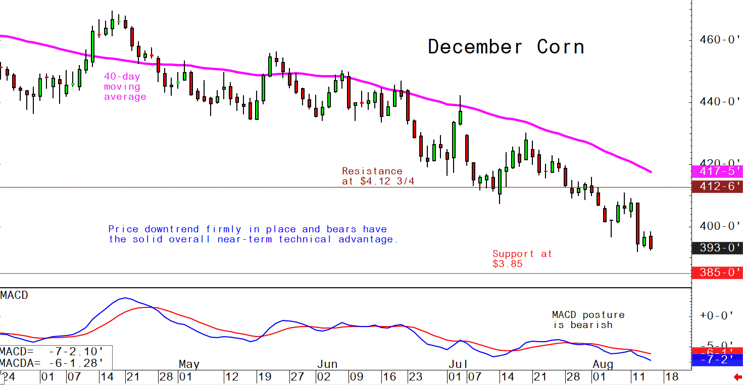
Wheat
Fundamental Recommendation: The balance sheet suggests lower prices, even with weather risk premium added, so we would carefully try to establish shorts in Sep 26. Liquidity and the robust cash-market demand for row crops continue to keep upside risk above levels suggested by the balance sheet. So, balance any short in Sep with inexpensive 10-delta calls in the nearby as a hedge, as long as volatility is not too expensive.

Fundamental Bullish Factor – Strong world wheat demand supporting export basis
Fundamental Bullish Factor – Developing dryness around major winter wheat areas, particularly ECB and Illinois will support strength from cash markets.
Fundamental Bearish Factor – USDA raised global production more than anticipated
Fundamental Bearish Factor – Russian wheat remains more competitive than other sources, limiting fresh export volumes
Fundamental Swing Factor – US weather conditions over the winter. Developing dryness surrounds major winter wheat growing areas threatening winter kill if the snow pack is absent.
Fundamental Swing Factor – Weekly export sales data will provide a window into US competitiveness and the pace of shipments.
Technical Recommendation: Sideways to Lower.

Technical Bullish Factor – Markets are short-term oversold and due for upside correction.
Technical Bearish Factor – SRW and HRW prices well below key 40-day moving averages.
Technical Bearish Factor – SRW and HRW prices in downtrends on daily charts.
Technical Bearish Factor – Down-trending corn market is bearish for wheat.

Wheat (continued)

CBOT Wheat Technicals
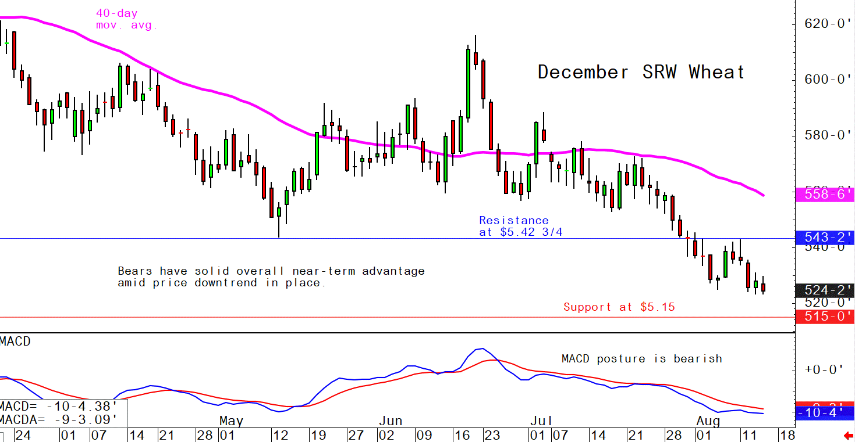

Soybeans
Fundamental Recommendation: Like the other row crops, the manic nature of traders’ responses to the “more bearish than expected, but still kind of bullish in a certain light,” means it is not a time for unhedged positions. If Brazilian production hits 175 million tonnes, selling into any increase in prices driven by the additional of seasonal weather risk premium will be wise. However, robust cash demand and nearly tight ending stocks encourage hedging with tiny calls (10-delta) in the nearby contract.

Fundamental Bullish Factor – Robust domestic US demand continues to support basis.
Fundamental Bullish Factor – Chinese buying has been viewed by the market as bullish with recent purchases driving the post WASDE recovery in prices.
Fundamental Bearish Factor – South American farmers are likely to produce another record-large crop.
Fundamental Bearish Factor – Chinese soybean meal demand remains lower than anticipated.
Fundamental Swing Factor – The volume of Chinese buying before the end of the year. It remains unclear that China needs 12.5 million tonnes of soybeans and despite recent purchases remains well short of the target heading into the holiday season.
Fundamental Swing Factor – Limited but potentially serious weather risk. Limited dryness in South America and growing dryness in the heart of the Corn Belt remain critical areas to watch.

Technical Recommendation: Sideways.

Technical Bullish Factor – Prices now above key 40-day moving average.
Technical Bullish Factor – Soybean meal market now performing much better.
Technical Bullish Factor – MACD indicator turns bullish.
Technical Bearish Factor – Slumping corn and wheat markets are bearish for beans.
Technical Bearish Factor – Longer-term charts are not friendly for beans.

Soybeans (continued)

CBOT Soybeans Technicals
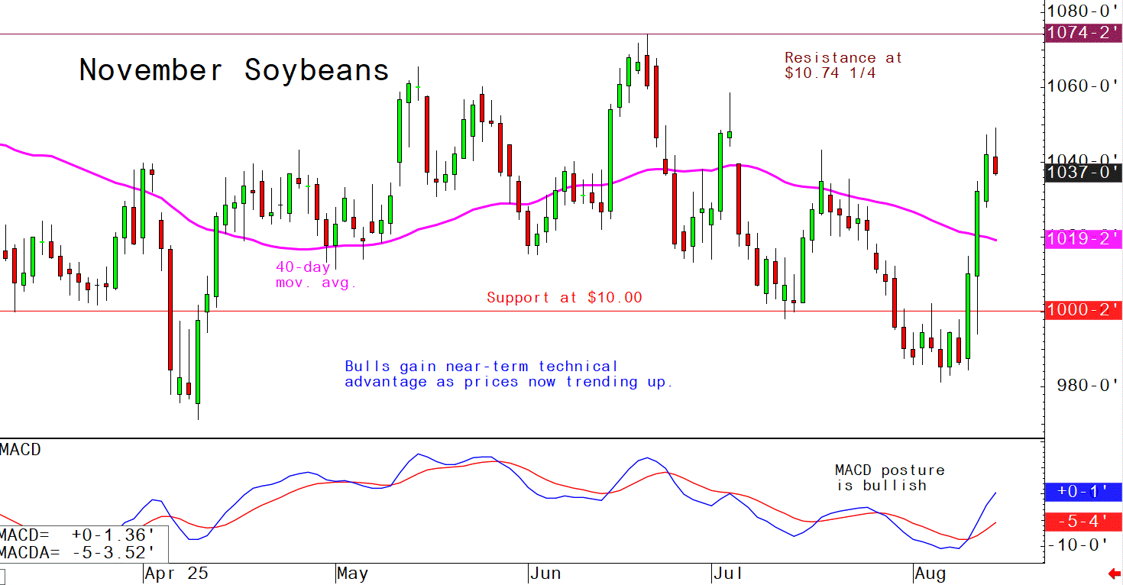
Soybean Meal
Fundamental Recommendation: Limited opportunities given robust domestic demand, but short Oct above $350 may be the only spot. Still, if weather concerns develop in South America or the Corn Belt, prices could move sharply high so limit risk by reducing position size or hedging.

Fundamental Bullish Factor – Cattle prices remain historically high, shifting consumer demand to pork and chicken, which both consume substantially more soybean meal per animal than cattle.
Fundamental Bullish Factor – Crushers continue to keep the domestic protein meal market tight enough to avoid crushing for oil.
Fundamental Bearish Factor – Record South American oilseed production will potentially substantially increase competition for soybean meal exports in 2025/26.
Fundamental Bearish Factor – Changes in biofuel policy announced early in the Trump Administration increase the potential demand for soybean oil, increasing the possibility that crushers could be driven to crush for oil by mandate.

Technical Recommendation: Sideways to Higher.

Technical Bullish Factor – Prices now trending up on daily bar chart.
Technical Bullish Factor – Prices above key 40-day moving average.
Technical Bullish Factor – Spreaders are unwinding short meal, long bean oil spreads.
Technical Bearish Factor – Market is short-term overbought, technically.
Technical Bearish Factor – Longer-term charts are not bullish.

Soybean Meal (Continued)

CBOT Soybean Meal Technicals
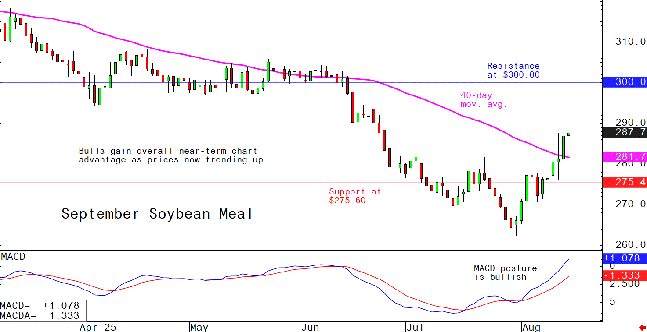

Soybean Oil
Fundamental Recommendation: Forecast models want to predict December substantially below our current outlook. Sell Dec above 60 cents, but if the South American crop is as large as expected that target may need to drop to 55 cents by the end of January.
Fundamental Bullish Factor – Continued demand pull from biofuel producers support domestic prices.
Fundamental Bullish Factor – Concerns about growing tightness in world vegetable oil markets due to production concerns with palm that are currently limited but could grow.
Fundamental Bearish Factor – Record South American production could limit the competitiveness of US exports in 2025/26.
Fundamental Bearish Factor – Falling crude prices could pressure margins heading into the time of the year when output, particularly at biodiesel plants slows dramatically.

Technical Recommendation: Sideways to Lower.

Technical Bullish Factor – Solid chart support levels just below the market.
Technical Bullish Factor – Rallies in soybeans and meal will limit downside in bean oil.
Technical Bullish Factor – Weekly chart is still friendly.
Technical Bearish Factor – Price downtrend in place on daily chart.
Technical Bearish Factor – Prices below key 40-day moving average.
Technical Bearish Factor – Slumping crude oil prices bearish for bean oil.

Soybean Oil (Continued)

CBOT Soybean Oil Technicals
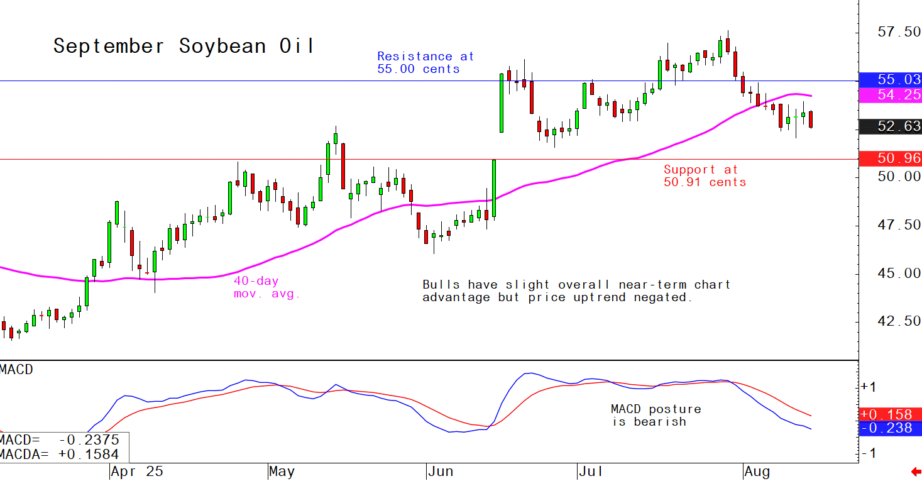

Agricultural Prices

